Exploring the Financial System of Madrasas in Gujarat with Focus on Sources of Funds and Its Utilizations

Ibadurrehman Patel1 [0000-0003-4797-5406] and Rusni Hassan2 [0000-0003-4332-9044]

1 IIUM, Institute of Islamic Banking and Finance Malaysia

2 IIUM, Institute of Islamic Banking and Finance Malaysia  
[ibadpatel39@gmail.com](mailto:ibadpatel39@gmail.com)

**Abstract.** The Main focus of this paper is to explore the financial system of Islamic educational institutions (Madrasas) of Gujarat specially where the income of these institutions comes from and how this fund is utilized. Madrasas are the main providers of Islamic education in India. From the conquest of India by Muslims majority of Islamic teachings is completely free till now because children from very low-income families almost exclusively populate madrassas. Unfortunately, since the British control, the Madrasas’ financial system has been completely overlooked, and both the number of donors of waqf land and the number of waqf properties have been steadily diminishing, though in some states like Assam, Bihar, Madhya Pradesh, Orissa, Rajasthan, Uttar Pradesh, and West Bengal few Madrasas receive financial aid from the government. This paper tries to explore the income and expenditure of the Madrasas in Gujarat state where Madrasas does not get any financial help. This study adopts qualitative research which includes annual audit reports of these institutions. It also gathers information from library and electronic resources. This research shows that Madrasas in Gujarat are more dependent on public funding in terms of Zakat, Sadaqah, Fitra, Fidya, Lillah (general donation), while wages, electricity, repairing, food, gift, program and exam, collection, travel, and hospitality of the guest are the main expenses associated to operate the Madrasas. This is one of the early studies that give analysis on the financial system of Islamic educational institutions in Gujarat.

**Keywords:** Islamic Educational Institution (Madrasa), Financial System, Income, Expenditure, Gujarat (India)

1. Introduction

As a vast country with its demography and dense population, India has struggled with the education index among the common population. India is a country with 1.38B people of religious, ethnic, and linguistic diversity, of which an estimated 195M or 14.2% of the population is Muslim (Muslim Population by Country, 2021), most of whom identify as Sunni, which constitutes the world’s third-largest Muslim population in the world after Indonesia and Pakistan, by far the largest minority group. According to the census, the 2011 literacy rate among Indian Muslims is 57.3%, far behind the national average of 74.4% (Ministry of Home Affairs, 2011).

Anyhow, Islamic educational institutions (Madrasas) try to give education to Muslim children, Madrasa education in India stretches back to the twelfth century when Muslims conquered India. From that time forward, Waqf sponsored most of the Islamic education, which was completely free. Unfortunately, since the British control, the madrasah education system has been completely overlooked, and both the number of donors of waqf land and the number of waqf properties have been steadily diminishing. Nevertheless, according to (Qasmi M. B., 2005) currently, educational institutions in India, known as Madrasas, fall into two categories as per their financial backup: In several states, including Assam, Bihar, Madhya Pradesh, Orissa, Rajasthan, Uttar Pradesh, and West Bengal, several Madrasas are associated with state governments. Even though they are small, these Madrasas receive salaries and funding from their respective governments. Again, there are four types of community-based Traditional Islamic educational institutions: (1) Maktab, (2) Darul Quran, (3) Madrasa, and (4) Jamia, which correlate to schools, high schools, colleges, and universities in the English language. All these four forms of Islamic educational establishments are collectively referred to as Madrasas by the general public. However, our focus here is on the second category, which includes Madrasa and Jamiah, supported and run via donations such as Zakat, Sadaqah, and regular contributions from the general public. Although no regular census of the types mentioned above of madrasas has ever been taken, government sources estimate that there are approximately 1,00,000 such institutions in India (Basheer, 2016). However, according to (Nair, 2009) overall, there are 1825 madrasas in Gujarat, of which 63 are in the category of Madrasa and Jamiah (Kapodravi, 2015).

However, (Sachar, 2006) makes a critical observation validating the view that children from very low-income families now almost exclusively populate madrassas. Therefore, these Madrasas must rely on either partial government funds or public funds in terms of Zakat, Sadaqah, Fitra and general donation. Madrasas in Gujarat state do not have any government-sponsored Madrasa education board like Assam, Bihar, Madhya Pradesh, Orissa, Rajasthan, Uttar Pradesh, and West Bengal (Ali, 2015). Therefore, they are fully dependent on the well-wisher’s fund. This study, hence, aims to identify the sources of funds and its utilization of Madrasas in Gujarat.

There is literature on protagonists of educational system (Dars-e-Nizami) the famous curriculum of Madrasas, as well as how the courses taught at Arabic Madrasas meet the needs of the students, reformation of Madrasa curriculum, interactions between the Indian state and Islamic madrasas, and their historical background in India, However, no particular research has been found on Madrasa in Gujarat, especially their financial aspects like sources of funds, its utilization and how it can be managed effectively. This is one of the early studies that give analysis on the financial system of Islamic educational institutions in Gujarat. Thus, this research will provide a way forward for the further research in the area of financial system of Madrasas in Gujarat.

1. Literature Review
   1. Islamic Educational institutions (Madrasa)

Madrasa is an Arabic term, meaning a place for Dars literally, that is to say, teaching. Public schools and educational institutions in Islamic countries are known as Madrasa. In Encyclopedia of Islam, (Esposito, 1995) described that Madrasa is a learning institution, in which theological studies about Islam, including philosophy and Islamic literature, are being taught.' Madrasas were initially distinguished as learning institutions that taught Quran only. Nevertheless, many Western observers subsequently used this term to draw attention to all schools that promote an Islamic curriculum, rather than primary, secondary, or advanced. (Bergen & Pandey, 2006) reported that Madrasas differ from country to country or even from city to city. They may be operated on a daily basis or as a boarding school or a school with a general curriculum, or as a strictly religious school linked to a mosque. Madrasa refers to an educational institution in several countries, including Egypt and Lebanon. However, in India, Pakistan, and Bangladesh, Madrasa frequently refers to Islamic religious schools. According to (Winkelmann, 2005) this Islamic educational institution, therefore, aims to educate students so that they can pursue the path that the Quran and Shariah have prescribed and spread Allah’s wisdom and message to humanity for the benefit of their physical, intellectual, and spiritual well-being. However, (Hasan, 2009) claims that the main purpose of these institutions is to establish graduates such as those from modern schools, except that they are more familiar with Islam. Historically, Madrasas have been a learning hub in the Muslim world, and they remain so until today (Ellis, 2007). The history of the Madrasa education system began from the Masjid al Nabawi (Prophet’s Masjid). There was a platform called Al-Suffa where the prophet (PBUH) himself used to teach his companions; later, they were known as Ashab-e-Suffa. The Companions and Ulama of Islam followed the same track, and up to the 9th century, there is no evidence of separate building centres for students (Mubarkpuri, 2000). It is somehow difficult to point out with certainty when and where the first separate madrasa was built. According to (Mubarkpuri, 2000) the first Madrasa, like that of the present time, was founded in Nishapur by Shafai Ulama. However, (Al-Faruque, 1987) stated that the minister Nizam ul Mulk Tusi is the pioneer in this field, and he established the first Madrasa in 1062 in Baghdad.

* 1. Evolution and growth of Islamic Educational Institutions (Madrasa) in India, including Gujarat

Madrasas were founded in India when the Muslim leaders arrived at the sub-continent. These institutions were created by the rulers and nobles of the state or were the result of the collective effort of the community. It is assumed that they were discovered in the area of Sindh and Multan first (Arshad, 2005). According to (Saklain, 1993) after the conquest of the northern part of the Sub-Continent (Sindh) by Muhammad Bin Qasim in 711 AD, Muslim scholars started to come and settle in its different cities and an informal setup of Madrassah was established in the city of Debal. (Tankarwi, 2012) claims in Gujarat, the first Madrasa was established by the Shia Bohra community in the time of king Sidhraj Jaisingh in the early 12th century. After that, several madrasas came into existence in the reign of Muslim kings. However, (Sikand, 2005) argues that Muhammad Ghori established a Madrassah in the city of Ajmer in 1191. It was considered the first formal institution established by any Muslim ruler in the sub-continent and from there spread to the northern parts of the country. Then, from the latter half of the 12th century to almost the end of the 16th century, there was a steady growth of madrasas under the patronage of the early Muslim and Mughal kings. Overall, during this time, madrassas gained financial support and respect from rulers and common citizens alike. The first conqueror of the Mughal era, Babar, is remembered for establishing (between 1526 and 1530) particular division for the advancement and administration of madrassas (Kidwai, 2015). Among the subsequent kings, Akbar (1556-1605) was especially noted for enhancing the access of common citizens to madrassas (Riaz, 2011). The Emperors Jahangir (1605-1658) and Aurangzeb (1658-1707) resurrected several old madrassas and improved financial arrangements for their upkeep and scholarships to poor students (Kidwai, 2015). They provided a substantial amount of land (jagirs) to religious schools. State-sponsored madrasas persisted even throughout the era of the last Mughal Empire of Bahadur Shah Zafar (Siddiqui, 1997). Thus, more than a thousand madrasas sponsored by the state are recorded to have been in operation during the pre-Mughal Tughlaqs and were widespread throughout the length and breadth of the country during Mughal rule.

However, there has been a concern in India about Madrasa education after the British enacted Legislation to seize overall Madrasa properties in India in 1828 (Nair, 2009), particularly since the first war of Indian Independence took place in 1857, Madrasas lost political patronage. As a result, traditional education institutions no longer had recourse to endowments in the form of free properties (Kidwai, 2015). Nonetheless, they continuously operated with the spirit of supporting the legacy of classical Muslim education in the Indian sub-continent amid the financial turmoil and the sequence of crises. Owing to the bitter experience of being governed by the colonial forces, the Muslims became more aware of their religious existence, producing many madrasas. The most prominent and popular among them was Darul Uloom Deoband and Mazahirul Uloom Saharanpur, established in 1866, Darul Uloom Nadwatul Ulama, founded in 1892 in UP, and Jamiah Ashrafiah of Rander in 1870 in Gujarat (Nadwi A. H., 1999).

Anyhow, nowadays there are many madrassas, both old and modern styles, in Gujarat. The Jamiah Islamia of Dabhel, established in 1908, was really a great institution once, claiming on its staff men of the calibre of Maulana Anwar Shah Kashmiri and Maulana Shabbir Ahmad Osmani (Nadwi A. H., 1999). Jamiah Husainiah of Rander was founded in 1917; Al Jamiah Al Islamiyyah Taaleem u Al Islam of Anand has been established in 1919; Al Madrasa Al Arabiyyah Li Taalimi Al Muslimeen of Lunawada was originally established in 1930; Darul Uloom Saadat u Al Darain of Sitpon was established in 1939; Darul Uloom of Chaapi was officially established in 1945; Al Jamiah Al Islamiyyah Imdad u Al Uloom of Wadaali was started in 1956; Darul Uloom Falah e Darain of Tadkeshwar was actually founded in 1964; Darul Uloom Al Islamiyyah Al Arbiyyah Matliwala of Bharuch in 1966; Darul Uloom Al Arbiyyah Al Islamiyyah of Kantharia in 1969; Darul Uloom Baroda of Tandalja was erected in 1972; Al Jamiah Al Qasimiyyah of Ratanpur in 1981; Darul Uloom Al Markaz Al Islami of Ankleshwar in 1984; Jamiah Mazhar u Al Saadah of Hansot in 1985; Jamiah Uloom u Al Quraan of Jambusar inaugurated in 1988; Jamiah Al Qiraat of Kafleta in 1996 and Jamiah Ameen u Al Quraan of Paanpur began in 1998 are the most notable (Kapodravi, 2015).

* 1. Types of Madrasas Based on Sources of Fund

For the thousands of Madrasas operating in India with the mission of spreading Allah's message to humanity, there are primarily two types of financial assistance to them:

### Charity based Madrasas.

This type of Madrasas is almost dependent on the support of charity. The majority of the Madrasas have their own charity collectors, commonly referred to as "Safeer," who go door to door to ask for donations from the Muslim community. Organizations such as the Jamiat Ulama-e-Hind and Rabta-e-Madaris-e-Islami issue certificates to Madrasas affiliated with them to certify their authenticity and charitable work (Nair, 2009). Occasionally, some Muslims make a large contribution to a Madrasa in terms of Sadaqah. Certain individuals make Zakat and Fitra contributions to certain institutions. During Eid-ul-Azha, Muslims frequently donate their charm-e-qurbani (slaughtered animal's skin) to Madrasas. However, certain Madrasas have permanent revenue streams, like lands, residential complexes, and other real estates that generate regular profits (Khan, 2003), but these types of Madrasas are very few.

### Government Grants Madrasas.

The government of certain states, including Assam, Bihar, Madhya Pradesh, Orissa, Rajasthan, Uttar Pradesh, and West Bengal, has established government-sponsored Madrasa education boards. While the government of these states provides some funding to these institutions, the number of such Madrasas is relatively small (Ali, 2015).

1. Research Methodology

This research adopted the qualitative method as it allows the researcher to collect financial reports of Madrasas in Gujarat which will help to exhibit the sources of funds for Madrasas and help to know their main expenses. This research is based on secondary data which is collected from sources such as published articles, books, websites, academic writings, and last 3 years annual audit reports of 7 Madrasas out of a total of 63 Madrasas approximately, though these reports are not accessible online and are very hard to get. Furthermore, an explanatory research type will be used, since no research conducted about Islamic educational institutions (Madrasa) of Gujarat (India), particularly from financial aspects.

1. Findings and Discussion
   1. Income and Expenditure Statements Analysis

The main objective of this study is to know the financial system of the institutions mentioned above, especially the income of these Madrasas, and how is it utilized as it has been discussed earlier that there is no study about the financial system of these institutions until now. Hence, the researcher tried to analyze the income and expenditure statements of seven madrasas for the last three financial years, categorizing the madrasas into three different classes according to the student’s capacity. The first category is the madrasas with the capacity of 400-500 students, the second category is the madrasas which have the capability of 700-800 students, and the last category is Madrasas, with 900-1000 students. The data presented below were taken from the tabular form of the income and expense statements in an excel sheet from which the main income items and expense items were represented in a bar graph for comparing the financial periods.

### Madrasa A.

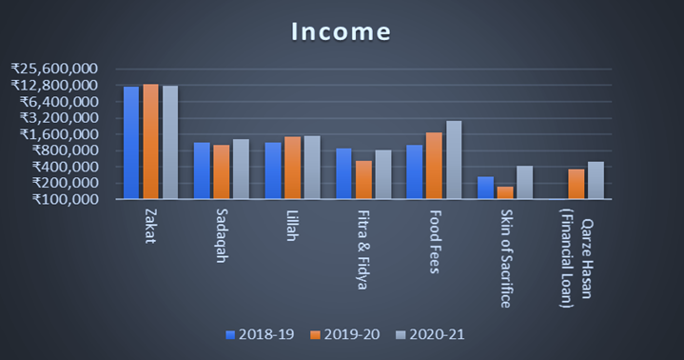

**Fig. 1.** Income Statement of Madrasa A

Source: Financial Statements of Madrasa A (2019-21)

According to the graph above, the main income of Madrasa is from Zakat, Sadaqah, Lillah and food fees in which income from Zakat is 12.3M, 13.3M and 12.5M for the past 3 years respectively, Sadaqah was 1.1M, 1M and 1.3M respectively, Lillah was 1.1M, 1.4M and 1.5M respectively and food fees were 1M, 1.7M and 2.8M respectively. Other income like Fitra & Fidya, the skin of sacrifice etc., amount to 1.2M, 1M and 1.7M, respectively.

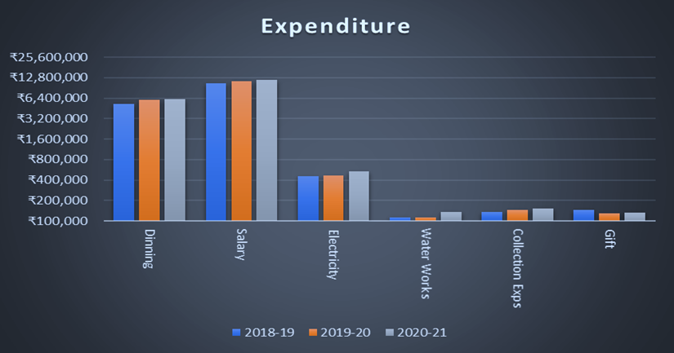

**Fig. 2.** Expenditure Statement of Madrasa A

Source: Financial Statements of Madrasa A (2019-21)

The graph shows that the expenditures incurred in Madrasa A are mainly in payment of salary, electricity, and food expenses. Salary expenditure was 10.4M, 11.M and 12M for previous 3 years respectively, electricity amount to 0.45M, 0.47M and 0.53M respectively and food expense incurred was 5.2M, 6M and 6.1M respectively, other expenditure like water works, repair and maintenance, gifts etc., amount to 0.65M, 0.79M and 1.1M respectively.

Anyhow, the major source of income was Zakat. However, the main expenditure incurred by Madrasa A is in paying salary to their staff members, which is supposed to be paid through income from Lillah and fees; since they have inadequate funds, they had to cover the salary expenses through Zakat and Sadaqah. It should be noted that for the past 2 years, the Madrasa had to take Qarz-e-Hasan (Financial loan) of 0.36M and 0.50M.

### Madrasa B.

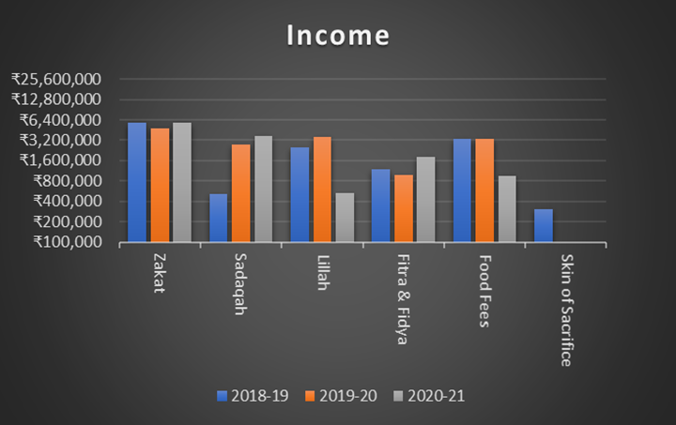

**Fig. 3.** Income Statement of Madrasa B

Source: Financial Statements of Madrasa B (2019-21)

As we can see from the graph above, the core income of Madrasa B is from Zakat, Sadaqah, Lillah, Fitra & Fidya, food fees and skin of sacrifice. Where the income gained from Zakat is 5.7M, 4.8M and 5.8M for the 3 years prior to the current year. The income of Sadaqah increased from 0.51M in 2018 to 3.7M in 2020. Income from Lillah was 2.5M, 3.5M and 0.53M respectively, and Fitra and food income were 1.1M, 0.97M and 1.8M from 2018-20, Fees collection was 3.3M and 3.3M for 2018-2019 and 2019-2020, but it dropped significantly to 0.94M due to Covid-19 pandemic.

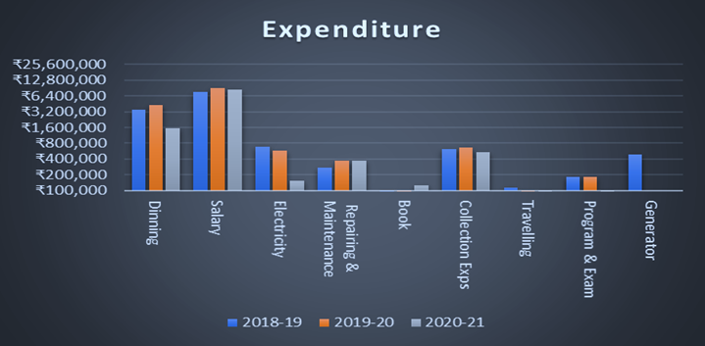

**Fig. 4.** Expenditure Statement of Madrasa B

Source: Financial Statements of Madrasa B (2019-21)

Expenses incurred by Madrasa B are mainly in paying salary, food expenses, electricity, collection expenses and repairing and maintenance. Salary paid amounted to 7.7M, 9.1M and 8.3M respectively. Food expenses were 3.5M, 4.2M and 1.5M for the past 3 years. Electricity expenses paid was 0.67M, 0.58M and 0.15M respectively. Collection expenses, including travel and collection salary expenses were 0.62M, 0.66M and 0.53M for last 3 years. Other expenses like program & exam, travelling, gift, guest, stationery, and printing expenses etc. amount to 1.3M, 1.1M and 0.8M respectively.

Considering the income and expenditure of Madrasa B, we can see that the main income of the madrasa is from Zakat and the main expenditure is the Staff salary, part of the salary is being paid through Zakat funds since there is a shortage of funds from Lillah and fees. It needs to be highlighted that the madrasa allocated a part of the budget to collect funds.

### Madrasa C.

**Fig. 5.** Income Statement of Madrasa C

Source: Financial Statements of Madrasa C (2019-21)

The above graph illustrates the main income of Madrasa C. They are Zakat, Sadaqah, Lillah, fees etc. The income from Zakat was 13M, 18M and 11M respectively for the past 3 years. Sadaqah was collected 10M, 2.7M and 2.8M for 3 preceding years. Income from Lillah was 1.4M, 15.5M and 8.5M respectively, Income generated from fees was 1.2M, 1.3M and 0.22M. Other incomes generated from the skin of sacrifice, gifts, school fees, ITI, NCPUL grant etc. which amounts to 2.6M, 2.8M and 0.79M. According to the income statement of Madrasa C, in the past 3 years, the Madrasa generated the highest income in the period of 2019-20, which was 40.5M and the lowest in the period of 2020-21, which was 23.4M due to the pandemic.

**Fig. 6.** A picture containing text, stationary, pencil

Description automatically generated Expenditure Statement of Madrasa C

Source: Financial Statements of Madrasa C (2019-21)

The expenditure graph highlights the main expenses incurred by the Madrasa for the past 3 years, Staff salary, food, electricity, repair, and maintenance and ITI and School. The Staff salary was 12.3M, 14.2M and 14M for past 3 years. Food expenses were 8.1M, 8.3M and 3M, respectively. There is a decrease in food expenses for the period of 2020-21 compared to 2 years prior to it because of few students in the madrasa due to the pandemic. Electricity expenses also saw a decline from 2.5M and 2.2M in 2018-19 and 2019-20 respectively to 0.87M in 2020-21 due to less electricity usage. ITI and school expenses incurred was 2.5M, 12.8M and 3.5M for the past 3 years. Repair and maintenance expenditure were 0.9M, 0.34M and 0.43M for the years 2018-2020. Other expenses amount to 3.7M, 2.8M and 1.9M.

We can see from the above data that in the period of 2018-19, Madrasa C had to pay salary and cover expenses by using the income from Zakat and Sadaqah in contrast to the period of 2019-20 in which Salary expense was paid with income generated from Lillah and other income other than Zakat and Sadaqah. It is to be noted that the income and expenditure of Madrasa C are more than the above mentioned 2 madrasas, Madrasa A and Madrasa B. Madrasa C has income from ITI, NCPUL grant and school fees, which is specifically used to cover expenses of ITI and school. However, the expenses incurred in ITI and school in the period of 2019-20 is 12.8M which was paid with income from unknown sources.

### Chart, bar chart Description automatically generatedMadrasa D.

**Fig. 7.**  Income Statement of Madrasa D

Source: Financial Statements of Madrasa D (2019-21)

The income graph of Madrasa D depicts that its main income was from Zakat, Lillah, Sadaqah, fees and skin of sacrifice. The Funds collected from Zakat were 5M, 5.8M and 6M. Funds from Sadaqah were 0.32M, 0.32M and 0.4M, respectively, for the past 3 years. Income gained from cash waqf was 9.8M, 10.5M and 12.1M. Lillah income was the highest income compared to all other items in the income statement. Food Fees income was 2.4M, 2.9M and 3.5M for the previous 3 years. Income from the sale of the skin of sacrifice was 3.5M, 2.9M and 2.5M, respectively, for the past 3 years.

**Fig. 8.** Expenditure Statement of Madrasa D

Source: Financial Statements of Madrasa D (2019-21)

Madrasa D’s expenditure chart shows that the expense of this Madrasa mainly consists of Staff salary, food expense, electricity, repair, maintenance, etc. Staff salary was 11.1M, 12.7M and 14M. Food expenses were 6.4M, 7.1M and 7.5M for the period from 2018 to 2020. Electricity expenses incurred have been consistent for all 3 years, which is 1.4M, 1.4M and 1.6M. Repairing and maintenance of the madrasa cost 1.1M, 0.4M and 0.5M for the preceding 3 years. All other expenses like stationery and printing, purchase of books, travelling, etc. totalled 1.1M, 1M and 1M, respectively.

Since Madrasa D has a large number of funds from Lillah and other income, including fees and miscellanies, they could pay Salary from that amount. Unlike the previous 3 madrasas, where the main income was from Zakat and salary had to be paid from the Zakat and Sadaqah funds.

### Madrasa E.

**Fig. 9.** Income Statement of Madrasa E

Source: Financial Statements of Madrasa E (2019-21)

The above graph portrays that the major income of Madrasa E is generated from Zakat and Lillah funds. Zakat collected amounts to 5.1M, 4.8M and 5.1M, respectively, which is about 75% of the total income. Lillah collected is 0.9M, 1.4M and 0.85M for the past 3 years. Other income includes share dividend, Sadaqah, Fitra and Fidya, food fees and rental income.

**Fig. 10.** Chart, bar chart

Description automatically generated Expenditure Statement of Madrasa E

Source: Financial Statements of Madrasa E (2019-21)

The expenditure of Madrasa E is incurred mainly in Salary, and dining expense which is 3.2M, 4M and 4M for Salary paid and 2.7M, 2.6M and 2M for dining expense respectively for the past 3 years. Other expenses include electricity, repair and maintenance, gas, collection expenses, travelling etc., which amount to 1M, 1.1M and 1.2M for the period of 2018-2020. The major expense incurred by the Madrasa is in dining expenses, and salary paid, which consist of more than 50% of the total expenditure.

The point to be highlighted is that Madrasa E has multiple sources of income like rental income and share dividend, which was not found in income statements of previously mentioned madrasas. As Zakat funds are the main income, staff Salary was paid with the Zakat funds, whereas it is supposed to be paid with income from Lillah, rental income and share dividend.

### Madrasa F.

**Fig. 11.** Income Statement of Madrasa F

Source: Financial Statements of Madrasa F (2019-21)

The above graph illustrates the income of madrasa F, which consist of Zakat, Sadaqah, Lillah, build fund, share dividend, food fees and grant fund. Zakat collected was 3.9M, 6.8M and 7.9M for the period of 2018-2020. Sadaqah was 3.2M, 5.1M and 6.3M respectively for the past 3 years. Lillah collected was 5.8M, 8.4M and 7.2M. The built fund was collected only for the period of 2018-19, which was about 4M. Other income consists of share dividend, food fees, grant fund amount to 1.8M, 1.6M and 1.5M in which grant from NCPUL is specifically used for the same purpose.

**Fig. 12.** Expenditure Statement of Madrasa F

Source: Financial Statements of Madrasa F (2019-21)

The major expenditure of Madrasa F was in Dining expenses, Salary and electricity, which makes up around 80% of the total expenditure. The other expenses include repair and maintenance, land revenue, stationery and printing, collection expense, school expense, travelling etc., which amount to 3.6M, 2.8M and 2.8M for the previous 3 years.

According to the financial statement of Madrasa F, in the financial period of 2018-19, the Madrasa incurred a loss of 0.2M, and in 2019-20 and 2020-21 period, the Madrasa had an excess of 1.5M and 1.5M respectively. Despite using the waqf land, the Madrasa has made an annual payment of land revenue to the government. The madrasa also has a school and other small branch of the madrasa, which have separate expenses.

### Madrasa G.

**Fig. 13.** Income Statement of Madrasa G

Source: Financial Statements of Madrasa G (2019-21)

As seen in the graph above, the Zakat collected makes up the majority of the income of Madrasa G. Other Incomes include Sadaqah, Lillah, Fitra & Fidya, fees, rental income, kitchen stock etc. Zakat funds were 20M, 23M and 20M respectively for the 3 years. Almost 70% of the income of the madrasa comes from the Zakat fund. Sadaqah amounts to 1.1M, 1M and 1.3M, Lillah income is 1.1M, 1.4M and 1.5M, fees collected amount to 1M, 1.7M and 2.8M respectively for 3 years preceding to the current year.

**Fig. 14.** Chart, timeline

Description automatically generated Expenditure Statement of Madrasa G

Source: Financial Statements of Madrasa A (2019-21)

A major part of the expenditure was incurred in food and Staff Salary which makes up 70% of the total expenditure. Other expenses include electricity, repair and maintenance, stationery, and printing, Staff Saving, Gifts etc. which amounts to 7.3M, 11.1M and 10.2M for the previous 3 years.

The madrasa has generated revenue from multiple sources like fees collection, program income, rental income etc., but still, the Madrasa had to take a Qarz-e-Hasan (Financial Loan) in the year 2019-20 to meet the expenses. In the period of 2020-21, Madrasa was only able to pay back part of the loan taken in the previous financial year, which shows that even after Madrasa had multiple sources of income, it was not able to fully repay the loan in one financial year.

1. Conclusion

Looking at the financial statement of the Islamic educational institutions (Madrasas) in Gujarat, it is discovered that total revenue and expense differ by Madrasa, depending upon the size of students and the facilities offered. Even so, the first segment of Madrasas, which educates 400-500 students, has a budget of nearly 10M INR, the second category, which teaches 700-800 students, has a budget of approximately 25M INR, and the third category, which enlightens 1000 students, has a budget of up to 40M INR. Apart from this, some Madrasas receive and spend more money than others because of quality of the services they give. Moreover, the main income of these institutions comes from Zakat, Sadaqah, Lillah, Fitra, Fidya, and fees, whereas nearly 80% of income is derived from Zakat, Sadaqah, Fitra, and Fidya, around 10% is obtained from Lillah, and the remaining 10% is sourced from fees and other sources. While wages, electricity, repairing, food, gift, program and exam, collection, travel, and hospitality of the guest are the main expenses associated with running the Madrasas. Most of the collected fund goes to wages, food and electricity expenses which are around 50%, 30% and 10% respectively, and the remaining 20% is allocated to other expenses. Compared to the cost of electricity, some Madrasas spend 10% of their total income on maintenance and repairs. However, salaries account for nearly 60% of total expenses in a few Madrasas, with food costs accounting for up to 30% of total expenses.

References

1. Al-Faruque, Muhammad. 1987. "The Development Of The Institution Of Madrasah And The Niẓāmiyah Of Baghdad." *Islamic Studies, 26(3)* 253-263.
2. Ali, MD Musa. 2015. "An Overview on Madarsa Education in India." *International Journal of Development Research, 5(03).* 3714-3716.
3. Arshad, Mohamed. 2005. Tradition of madrasa education. Madrasas in India-Trying to be Relevant. New Delhi: Global Media Publications.
4. Basheer, K. Mohammed. 2016. Quality Enhancement in Madrasa Education: An Exploratory Study. Cambridge Scholars Publishing.
5. Bergen, Peter, and Swati Pandey. 2006. "The madrassa scapegoat." *The Washington Quarterly 29(2)* 115-125.
6. Ellis, Tiffany. 2007. *Madrasas in Bangladesh.* New Delhi, India: Institute of Peace and Conflict Studies (IPCS).
7. Esposito, John L. 1995. The Oxford Encyclopedia of the Modern Islamic World. Oxford University Press.
8. Hasan, Noorhaidi. 2009. "The Salafi Madrasas of Indonesia." In *The Madrasa in Asia*, by Yoginder Sikand and Martin van Bruinessen Farish A Noor, 247-274. Amsterdam University Press.
9. Kapodravi, Abdullah. 2015. Azwaun Ala Tarikhil Harkatil Ilmiyyah wal Maahidil Islamiyyah wal Arabiyyah fi Gujarat Alhind. Kapodra, Bharuch, Gujarat, India: Majlisul Ma'arif.
10. Khan, A. U., Saqib, M., & Anjum, Z. H. 2003. "To Kill the Mockingbird: Madarsah System in India: Past, Present and Future." *The India Mosaic.*
11. Kidwai, Huma. 2015. Postcolonial challenges to madrassa education reform in India: Bureaucracy, politics, resistance, and cooptation. Teachers College, Columbia University: ProQuest Dissertations Publishing.
12. Ministry of Home Affairs, Government of India. 2011. *Census of india.* https://www.censusindia.gov.in/2011census/population_enumeration.html.
13. Mubarkpuri, Maulana Qazi Athar. 2000. Khair ul Quroon Ki Darasgahain Aur Unka Nizame Taleem o Tarbiyat. Lahor: Idara Islamiyat.
14. 2021. *Muslim Population by Country.* August 31. https://worldpopulationreview.com/country-rankings/muslim-population-by-country.
15. Nadwi, Abul Hasan Ali. 1999. Contributions of Muslims To Indian Subcontinents Translated from Arabic By Muhammad Asif Kidwai. Ankara: Sayo Publications.
16. Nair, Padmaja. 2009. *The State and Madrasas in India.* Birmingham, UK: University of Birmingham.
17. Qasmi, M. Burhanuddin. 2005. "Curriculum of Indian madrasas: need for reform." *The Milli Gazette Online.*
18. Riaz, Ali. 2011. "Madrassah Education in Pre-colonial and Colonial South Asia." *Journal of Asian and African Studies, 46(1)* 69-86.
19. Sachar, Rajendra. 2006. *Sachar Commitee Report.* Delhi: Government of India.
20. Saklain, G. 1993. *Sufi’s and Holy Men of Bangladesh.* Dhaka: Islamic Foundation Bangladesh.
21. Siddiqui, M K A. 1997. Institutions and associations of the Muslims in Calcutta : a preliminary survey. New Delhi: Institute of Objective Studies.
22. Sikand, Yoginder. 2005. "Bastions of the believers: Madrasas and Islamic education in India." *Penguin Books India.*
23. Tankarwi, Muhammad Iqbal. 2012. *Arab Mamalik Aur Suba e Gujarat Ke Talluqat.* Bharuch: Abu Bakar Rabi Ibn Sabih Library.
24. Winkelmann, Mareike Jule. 2005. From Behind the Curtain A Study of a Girls' Madrasa in India (p. 176). Amsterdam University Press.