Natural and Industrial Origin Reinforced LM6 Aluminum Matrix Composite Materials – A Comparative Study
Mutlag Sh. Fuhaid¹, M A Maleque^{1*}, R V Murali², and M. A. Rahaman¹
¹Department of Manufacturing and Materials Engineering, International Islamic University Malaysia, Kuala Lumpur, Malaysia; e-mail address: mutlagshafi@nu.edu.om, mutlaq.shafi@gmail.com, maleque@iium.edu.my , mrahman@iium.edu.my
²Research & Development Centre, Sri Krishna College of Technology, Coimbatore, India; e-mail: murali.rv@skct.edu.in, drmuralivenkat@gmail.com
corresponding author’s e-mail address: maleque@iium.edu.my
Abstract. Aluminum alloy is one of the most common and basic metallic alloys used as a matrix phase of composite material due to its higher strength-to-weight ratio, enhanced thermal conductivity, excellent stiffness as well as wear and corrosion resistance properties. Aluminum based composite materials have become an obvious entry into many industries such as automobile, aerospace, construction, household appliances, and food packaging industries. The common reinforcement materials to fabricate aluminum composites are aluminum oxide, silicon carbide, boron carbide, boron nitride, titanium carbide, tungsten carbide and titanium diboride. However, most of the ceramic based reinforcement materials are expensive and not environmentally or human friendly. Recent research has been tailored to the use of industrial waste as a reinforcement for aluminum composites such as slag, red mud, fly ash, arc furnace dust and waste glass. The use of natural materials such as glass and marble waste is promising because they are cheaper than conventional ceramic reinforcement and they also might enhance the properties of the composite. Therefore, this study aims to make a comparative study for mechanical and physical experimental work on using 5% marble wastes (MW) as a natural reinforcement and 5% graphene oxide (GO) as an industrial origin reinforcement in LM6 aluminum composites. Mechanical testing methods like tensile test, hardness and impact test are conducted. Elemental analysis and microstructure properties using optical microscope and SEM and EDS to study the homogeneity of particles distributions and type of fracture surface. The results showed the superiority of GO over MW where the Ultimate Tensile Strength (UTS) increased by 45% in GO, while 16% in MW. The value of Rockwell hardness of both composites materials was obtained which is more than doubled than that of LM6 alloy material. The Impact test rate increased in LM6/MW by 19% while approximately LM6/GO 36%. Marble waste and graphene oxide particles were homogeneously distributed in the matrix, and a strong bond was formed between the aluminum and the reinforced partition.
1. Introduction
Over the last few decades, there has been a growing demand for modern, stronger, and stiffer yet lighter-weight materials in the aerospace, transport, automotive and construction industries. Because of rapidly advancing activities in the automotive and aerospace industries, composite materials are developed primarily to increase technology demands [1]. Materials Scientists constantly explore all ways and means by which innovative and advanced materials can be developed to meet the ever-changing requirements with unique enhanced material properties.
Composite materials, since their inception, have proven to a potential alternate material to replace many conventional metals and alloys due to enhanced mechanical and physical properties. Composite materials are multiphase materials which are immiscible within each other and have a low specific gravity that makes them especially superior in strength and modulus to their properties.

2. Background Review
Processing and manufacturing composite components with current technology are more expensive due to difficulty in materials inspection, trouble shooting, and reusing constituent materials. The cost, characteristics, and availability associated with reinforcing phase would also add to the composite making's higher total cost. Table 1 shows a comparison between the use of conventional Al alloys and its composite in terms of costs and component weights. It is quite clear that although there is a huge weight reduction (86%) and the number of parts used (64%) when composite is recommended, the cost of composites has almost doubled (93%) and not comparable with that of Al Alloys. However, due to improving mechanical properties in composites will make operating costs over the long run of service less and break even the differences much quickly[2].
Materials used | Number of parts | %decrease in number of parts | Weight in kg | %decrease  in weight | Estimated Cost $ | % increase in cost
Aluminum | 117 | 64% | 12959.35 | 86% | 91857.08 | 93%
AL composite | 42 |  | 1873.30 |  | 178141.63
Table (1) Comparison of estimated material parameters for Al and its composites

Therefore, it is crucial for high-intensive composite users such as aerospace and automobile industries to carefully select the materials before pressing them into manufacturing. Researchers are also working on various solutions to lower the cost of composites, including improvements in manufacturing process performance. Several alternatives may be explored, such as single-step mixing, and utilizing lower-cost reinforcements.
Because of their excellent tribological properties in comparison to base alloys, the use of aluminum matrix materials in the transportation and aerospace industries is increasing rapidly. Because of their lower density, good formability, modulus, high, wear and tensile strength, metal-matrix composites, such as magnesium or aluminum are finding large use. They are used in various vehicle parts such as pistons, valve assemblies, blocks, and gaskets. Aluminum-based composites reinforced with Nano SiC, Al₂O₃, TiO, ZrO, SiO, and graphite particles change the microstructure to produce superior mechanical and physical properties [3]. However the issue is the cost and average price of composites. Eventually, some researchers used industrial waste materials like slag, red mud, fly ash, arc furnace dust, and waste glass to reinforce aluminum matrix phase to turn them into composites. The reuse of industrial wastes reduces environmental pollution through landfills. A new class of strengthening additives has recently emerged in novel carbonaceous (CNTs) nanomaterial, namely carbon nanotubes, fullerene, and graphene oxides. The following section showed a variety of industrial waste materials being used as reinforced phase material for the production of AMCs.
2.1. Waste for Refining (Spent Alumina Catalyst): Catalysts are used in oil refineries to crack petroleum products in hydro-processing systems. Catalysts are rejected from the units over time and become solid waste. Because of their dangerous nature and harmful chemical content, spent catalysts must be disposed of according to strict environmental regulations[4]. As a result, preliminary research has been conducted to produce AMC using scrap aluminum alloy wheel (SAAW) as a matrix material. As reinforcement, oil refinery waste such as spent alumina catalyst (SAC) (5 % mass fraction and particle size 150 µm) was used. Microstructural analysis, however, reveals that the addition of SAC to the matrix resulted in porosity in the composite material[5].
2.2. Red mud: Red mud is an industrial waste product generated during the aluminum production process from bauxite ore. This waste material is released into the environment, causing soil, water, and air pollution. As a result, research has been conducted on red mud to use as an alternative reinforcement because it is relatively cheaper, natural, and abundant. Using the stir casting technique, the authors of (Singh and Chauhan 2017) created aluminum 2024 matrix hybrid composites reinforced with Sic (5%, mass fraction) and red mud (5-20%, mass fraction) particles. In their study, the composites' mechanical properties, such as tensile strength, improved as the amount of red mud used as reinforcement increased. The red mud particles (particle size 37$μ$m) were homogeneously distributed in the microstructure of the hybrid composites [6].
2.3. Fly Ash: It is one of the residues generated by flue gas during the combustion of coal solids and is a waste by product. It is the most affordable and low-density reinforcement material available in large quantities in electric power plants[7]. Bharathi created the composite material using the stir casting technique, with LM25 as the matrix and fly ash forms as the reinforcement phases (5% wt). The hardness of the composite metal reached 125 HV [8].To manufacture the composite material, the stir casting process was used to fabricate the metal matrix composite using LM6 as the matrix and two separate forms of fly ash (type-A and Type-B) as the reinforcement phases. As compared to type-A fly ash, type-B fly ash had improved mechanical properties such as impact strength, tensile strength, and hardness. The fly ash particles are evenly blended with the matrix content [6].
2.4. Electric Arc Furnace Dust: Electric arc furnace dust (EAFD) is a hazardous solid waste generated during the steel manufacturing process. The use of dust from these factories prevents it from being disposed of in toxic waste landfills. It saves money. Oliveira et al. used powder metallurgy to create aluminum matrix composites reinforced (5 % wt. and 53 µm) with EAFD particulate. The addition of EAFD to the aluminum matrix resulted in improved micro hardness values of up to 85.09 5.7 HV [9].
2.5. Slag: It is a waste that is removed from the industry of steel. Slag is produced routinely throughout the year in large volumes. The industry was encouraged to look for an alternative way to manage its waste through-products by rigorous environmental legislation. In article [10], the authors used an aluminum slag composite powder metallurgy process. The addition of five percent slack to the aluminum matrix resulted in a compressive strength gain of up to 372MPa.
2.6. Waste Glass: Pollution from waste glass is prevalent across the world, both in terms of health risk and quantity. Mercury and lead present in the waste cathode ray tube (CRT) and lamp glass are the major pollutants. Bernardo et al, Fabricated aluminum reinforced glass matrix composites via cold-pressing and viscous ﬂow sintering. Fracture toughness has been conducted on the waste glass and aluminum matrix composites, which had revealed the maximum bending strength increase about the unreinforced matrix and a very low standard deviation[11].
2.7. Mines Waste: Mine waste causes contamination to the land near mines. It causes a severe threat to humans, animals, plants, and microorganisms near mine sites ([12]. Siva et al. investigated AMC, which is developed using aluminum matrix and mines waste-(CS) colliery shale material as reinforcement. The developed AMC has shown improved mechanical properties. SEM micrographs of the produced composite revealed very ﬁne particles with different shapes and sizes distributed uniformly across matrix material. The fabricated composite has shown better machinability[13].
2.8. Marble Waste: Ceramic artworks is another prospective area where the waster powders of marble could be employed as fillers. The authors of another study in the year 2017 have assessed the possibility of the use of marble waste (MW) powders in the production of stoneware clay bodies. Many samples of clay body specimens with marble waste up to 27% were prepared and evaluated for parameters. The tests' results show that the utilization of marble waste in stoneware body is very advantageous for ceramic artwork production[14].The authors took another specific application of marble waste powders in the year 2020 to evaluate untreated marble waste's suitability as an active pigment in paints. Authors have conducted a weatherability test, which demonstrated that the addition of marble waste powders to the colours enhanced much durability and integrity under high-temperature conditions. Therefore, this study opened up another promising alternative waste material for producing paints[15].
2.9. Graphite building materials: Recently, a particular type of graphite building materials called graphene oxide (GO) is used to control the corrosion on the metallic surfaces after implemented as an anti-corrosive coating material. It is reported that GO consist of a large number of ‘carboxyl’ groups that impart incredible wettability, dispersibility and surface activity characteristics[16]. The name graphene attributes to the compact honeycomb structure of carbon atoms which has the ability to be wrapped into thin sheets and rolled into nanotubes or piled up into laminates. This ability is brought about by a specific way in which the carbon atoms are bonded with surrounding atoms in this microstructure[17]. Fuhaid, used 5% graphen oxide nanoparticles with (LM6 alumnium alloy). The tensile strength of the composite material was improved by 45%, and the hardness of the composite material was more than twice that of the LM6 alloy material[18].
In summary, many industrial and natural waste materials are being extensively tested to determine if sustainable, cost-effective, and equally robust composites can be produced and used for automotive applications. In this paper, the mechanical properties of natural waste represented by marble waste and industrial waste represented by graphene oxide will be compared in addition to its suitability for automotive applications,
3. Material and Methods
The current paper characterizes LM6/GO industrial origin and LM6/MW neutral origin composite materials in order to assess their suitability for automobile applications. As a result, LM6 was chosen as the matrix phase material, and it was reinforced with a 5% volume fraction of GO and MW particles to create the composite materials. The LM6 aluminum alloy was obtained from Metal Engineering Company LLC in Oman, the GO powder (size, 5-10 μm) from Platonic Nanotech Private Limited, and the MW powder (size, 75 μm) from Natural Stone Company LLC in Oman. Table 1 shows the chemical compositions of GO and MW particles. The continuous stir casting process has traditionally been used in the production of composites. This method entails melting and continuously spinning the matrix-phase material into a barrel while gradually adding the refurbishment material in the oven.
Table 1. The chemical compositions of GO and MW particles.
Chemical composition for partials
GO |  | MW
Element | WT.% | Element | WT.%
C | 61.67 | SiO2 | 0.29
O | 37.89 | Al2O3 | 0.05
Na | 0.27 | Fe2O3 | <0.04
S | 0.18 | MgO | 0.36
 |  | CaO | 55.86
 |  | TiO2 | <0.01
 |  | P2O5 | <0.01
 |  | MnO | <0.01

Table 2 and Table 3 present the value of chemical composition and mechanical properties of LM6 aluminium alloy, respectively.
Table 2. Chemical composition LM6 aluminium alloy

 | Elements
Materials | Cu | Mg | Si | Fe | Mn | Ni | Zn | Pb | Sn | Ti | Al
LM6Aluminum (Cast alloy) | 0.1 | 0.1 | 13 | 0.6 | 0.5 | 0.1 | 0.1 | 0.1 | 0.05 | 0.2 | balance

Table 3. Mechanical properties of LM6 aluminium alloy

 | Mechanical Properties
Materials | Elastic Modulus(GPa) | Tensile Stress (MPa) | 0.2% Proof Stress (MPa) | Brinell Hardness | Elongation (%)
LM6Aluminum (Cast alloy) | 71 | 110-190 | 60-70 | 50-55 | 5%

The distribution of reinforcement materials within the matrix phase structure is determined by the operating temperature, kiln rotation speed, and volume of strengthening phase materials within the kiln. However, due to increased advantages, the squeeze casting technique has recently been used. As shown schematically in Figure 1, the stir squeeze casting setup was changed to stir the molten metal with reinforcement and hydraulic forging before solidification.
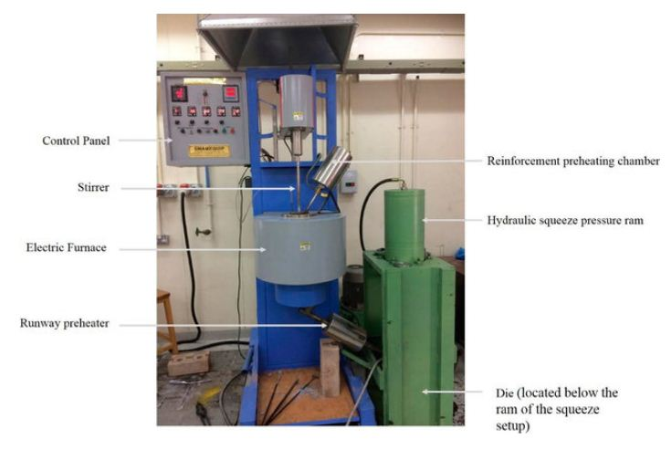
Figure 1. Modified Stir Squeeze Casting Machine
The solid LM6 alloy was heated to 750ºC, which is above its melting point, during this process. The molten metal was stirred for 10 minutes at 525 rpm to achieve a homogeneous mix before being poured into the die and immediately forged using a hydraulic press under a relatively high external pressure of 75 MPa. Table 4 displays the process parameters used in the stir casting process to create the LM6/GO and LM6/MW composites.
Table 4. Process Parameters of Stir Squeeze Casting Process
S No | Process Parameters | Value
1 | Stirring temperature | 750ºC
2 | Stirring speed | 525 rpm
3 | Stirring time | 10 min
4 | Preheat temperature of reinforcement particles | 300ºC
5 | Preheat temperature of the permanent die | 250ºC
6 | Squeeze pressure | 75 MPa
7 | Matrix material (LM6) | 95%
8 | Reinforcement material (MW) | 5%
9 | Reinforcement material (GO) | 5%

The morphological, microstructural, and crystalline phases of matrix (LM6) and reinforcement (GO) and (MW) materials and their composites were investigated using the methods described below.
3.1. Optical Microscopy (OM): The most effective non-destructive method for analysing the interstitial and replacement arrangements of atoms, impurities, or doping elements within a substance. This real-time imaging technique is extremely accurate and flexible for studying the microstructure of a variety of engineering materials.
3.2. Scanning Electron Microscopy (SEM): This method involves scanning material surfaces with a stream of electrons at varying thicknesses in order to analyse the topography and perform defect analysis. Appropriate scanned photographs of the surface at different locations reveal the composition of the specimen under examination. In this study, a Jeol Company, Japan, JSM-7600F Schottky Field Emission Scanning Electron Microscope with resolutions of 1.0 nm (15kV) and 1.5 nm (1kV) was used.
3.3. Mechanical Testing: Mechanical testing was carried out on the LM6 alloy, LM6/GO, and LM6/WM composites to assess the strength consideration before and after the composite manufacturing process. Showed that the samples performed according to ASTM E-8 according to the universal testing machine (UTM). The hardness of the composite was measured using the Rockwell hardness tester. The Charpy impact test measures how much energy a substance absorbs during a fracture. The energy consumed is an indicator of the hardness of the material. A standard sample was used (10 mm × 10 mm ×55 mm) according to ASTM A370.and the results are presented in the following section.

4. Results & Discussion

The microstructures of the LM6, LM6/MW and LM6/GO were examined and characterized for the nature and morphology of the grain structure and distribution of other intrinsic features in the microstructure. Figure 2 shows clearly distinguishes the LM6 alloy and the reinforcement of MW and GO particles. One of the unique features demonstrated is dense and nonporous microstructure. It is to be observed that the composites' better mechanical properties can be explained by the filler effect provided by MW and GO powders and the densification of constituents of the composite. Also noted is that the particle distribution of marble waste is acceptable because the particles are distributed across all parts of the LM6, because of the 75 µm particle size. The GO particles' surface is seemingly lined up and equal distribution of the particles in LM6, thus demonstrating strength layered structure. The main reason is nano-size of GO particles in which Strong bonding was formed between the aluminum and reinforce particles.

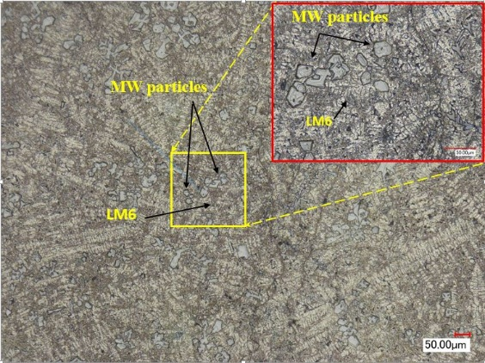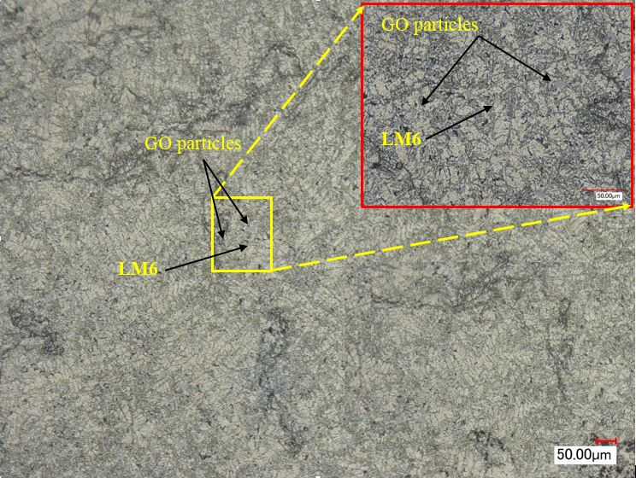
b
a

Figure 2. Optical Microscopic Image (a) LM6/MW (b) LM6/GO composites

The reinforcing phases' homogeneous distribution is the first prerequisite for a composite material to demonstrate superior efficiency. The agglomeration of the reinforcement particles degrades the composite's mechanical properties[19]. The ease with which the various metals can be mixed is one of the benefits of stir squeeze casting. This opens up the possibility of creating new composite materials with specific physical and mechanical properties in a product that cannot be manufactured using the normal melting-casting method. There were no large agglomerations of MW particles, as shown in figure 3 (a), but there was some porosity with size rate ranges 31.36 μm at the rate of 9.457 % and particles size rate 65.74 μm. This is due to the fact that fine particles are easier to integrate into metal during mixing and have a more uniform reinforcement distribution. Larger particles are more prone to gravity settling, resulting in reinforcement clustering and agglomeration in the matrix area. The embedded GO particles are not symmetric and non-uniform in size, with relatively larger surface areas, as shown in Figure3 (b). This is due to the various sizes of GO ranging from 5-10 micron where the particles size rate is 6.254 μm. However, the bonding between the LM6 matrix and GO is strong due to GO's superior wettability with a matrix material. Furthermore, in a nutshell, the above characteristics showed the viability and suitability of these composite materials. Smaller reinforcement particles have a wider surface area for contact with aluminium particles. On the other hand, larger reinforcement particle sizes discourage contact and thus the diffusion process from advancing. GO particles act as dislocation flow barriers in an aluminum matrix. Composites reinforced with smaller GO particles have the most barriers per unit compared to composites reinforced with MW particles at the same percentage of reinforcement. It was noted that the average porosity size was 3.45 μm at the rate of 10.131 % greater than that of MW.
a

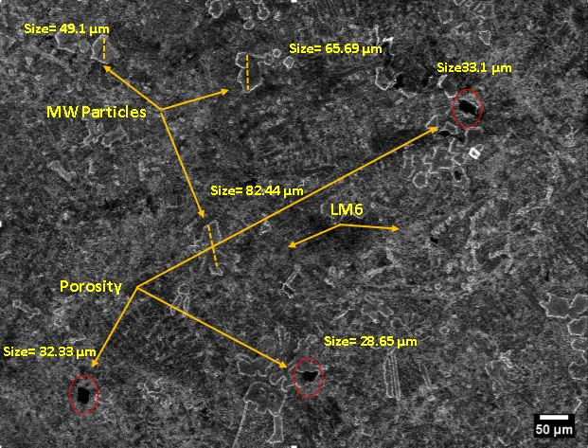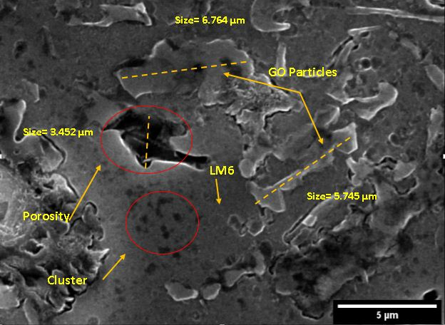
b

Figure 3. SEM Image (a) LM6/MW (b) LM6+GO particles

The UTM was used to generate stress-strain curves for several samples. The ultimate tensile strength of pure LM6 alloy was found to be around 110 MPa, while three composite LM6+MW specimens were found to be around 121, 123, and 140 MPa, respectively. The tensile value of LM6/MW was found to have increased by approximately 16%. This means that the aluminum alloy reinforcement of 5% of the marble waste effective. However, the extension rate was reduced by 65 %, implying that the toughness was reduced by 65 %. The same numbers of the sample were conducted of the LM6 reinforced by 5 % Graphene oxide composition, as shown in figure 4. The test results are average from three different tests of the sample. It was observed the composite LM6/GO registered around 140, 157 and 170 MPa, respectively. It was observed that the tensile value of LM6/GO increased by approximately 45 %. This means that the aluminum alloy reinforcement of 5% of the graphene oxide was successful. On the other hand, the extension rate was reduced by 53 %, implying that the toughness was reduced by 53 %.

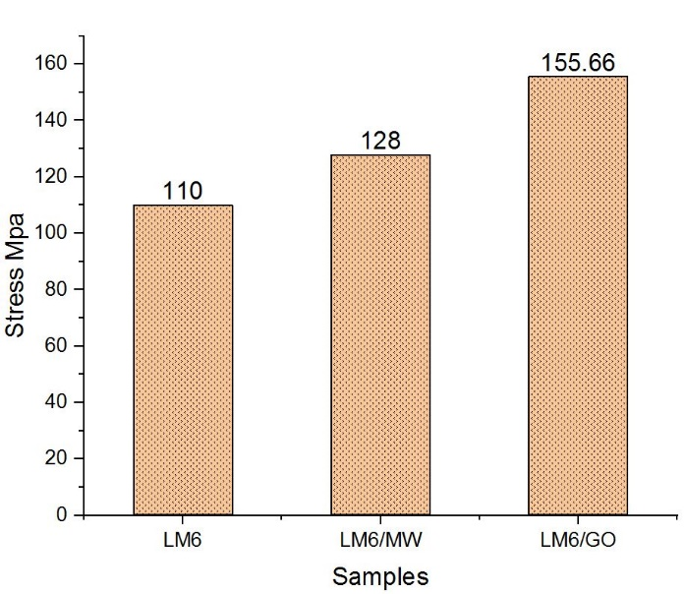

Figure 4. Tensile strength graph for LM6, LM6/MW and LM6/GO composites

Hardness Test by Rockwell scale machine was used to perform the all samples aluminum alloy LM6 and LM6+marble waste with LM6+graphene oxide. Five hardness reading registered for all specimens as shown in the table 5.

Table 5. Showed Rockwell Hardness values (HRF)
Specimen Type | Read1 HRF | Read2  HRF | Read3  HRF | Read4  HRF | Read5  HRF | Rate  HRF
LM6 | 75.5 | 78.3 | 74 | 74.8 | 75 | 75.52
LM6/MW | 95.1 | 94.8 | 93.9 | 95.5 | 94 | 94.66
LM6/GO | 92.8 | 98 | 93.1 | 94.5 | 95 | 94.68

The hardness test results for LM6, LM6 / MW, and LM6 / GO composites are shown in Figure 5. It was demonstrated that the hardness values of the resulting compounds increased by 25% as compared to LM6 Al pure alloys.

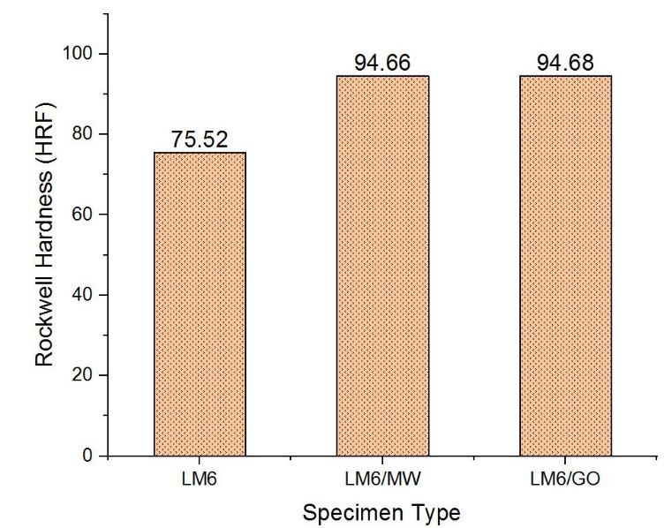

Figure 5.Hardness test for LM6, LM6/MW and LM6/GO composites

Interestingly, the hardness values increased in both aluminium composite materials. The reinforcement phase did affect the mechanical properties very much with 5% volume reinforcements. The higher hardness is because of C carbon in MW particles and GO particles. The nano-carbon elements with GO are the source of the high hardness of GO. However, MW can be captured using CaO calcium oxide as a carbon sorbent. At temperatures ranging from 550 to 800 °C, this sorbent also demonstrated nearly 100% carbonation[20].

An impact test is needed to determine the absorbed energy required to break the composite material. The impact examination for all specimens is depicted in figure 6. The energy absorption rate in LM6/MW increased by 19%, while it increased by approximately 36% in LM6/GO. This means that the addition of particles (marble waste and graphene oxide) to the aluminum/LM6 composites increased the absorbed energy necessary to break the material. It also denotes the increased toughness of the new composites that resulted.

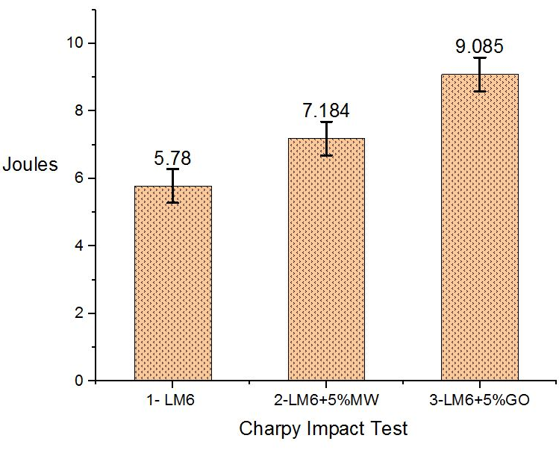

Figure 6 Impact test for LM6, LM6/MW and LM6/GO composites.

The particles that reinforced aluminum alloy /LM6 are the obvious cause of this rise in the ductility of composite materials. Because of the nanoparticle scale, graphene oxide outperformed on marble waste.

The failure of LM6 alumnium alloy samples reinforced with 5% MW and GO was extensively investigated to identify the causes of failure in tensile test samples as shown in figure 7.
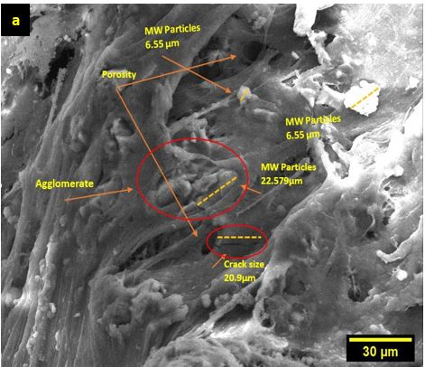
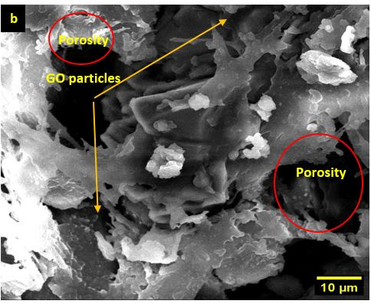

Figure 7 SEM tensile fracture surface of (a) LM6/MW (b) LM6/GO composites.

Cracks, some porosities, and a small agglomeration of LM6/MW composite were discovered. The tensile fracture surface in the LM6/MW specimens was not observed in the MW particles. MW particles had not started to fracture. However, the fracture due to matrix cracking, matrix cavitation, and interface decohesion and rupture, as shown in figure 7(a). Tensile loading fractures are ductile. Because of the high stresses and plastic zone that forms ahead of the crack edge, the mechanisms of damage accumulation and crack propagation vary. According to the most commonly accepted mechanism, microcracking occurs ahead of the crack tip as a result of matrix void formation within particle clusters as well as particle fracture and decohesion[21]. There is no void forming or debonding at the matrix–reinforcement interface in LM6/GO. Strengthened matrix–reinforcement interfacial bonding, although there is no debonding. Consequently, the failure tends to be caused by the accumulation of internal damage caused by matrix material deformation. This failure mechanism introduces voids that expand and lead to reduced ductility, which has played an important role in the tensile test. As it appeared, the tensile strengths increased with the nanoscale of the GO particles. This is due to an increase in the number of particles per unit area of LM6. As particle size decreases, the number of particles per unit area increases, making it achieve homogeneous particle distribution, resulting in difficulty creating preferential sites for crack formation and propagation, as shown in figure7(b).
5. Conclusion
The laboratory's modern microstructural analysis equipment was used to successfully synthesize and characterize LM6/MW and LM6/GO composites using a modified stir casting process. To create composites specimens, a squeeze stir casting machine was used. The results demonstrated grapheme oxide's superiority over marble wastes, with the UTS increasing by 45% in GO and 16% in MW. The Rockwell hardness of both composite materials was determined. More than a quarter of the hardness of the LM6 alloy material. The impact test rate in LM6/MW increased by 19%, while it increased by 36% in LM6/GO. The matrix was homogeneously distributed with marble waste and graphene oxide particles, and a strong bond was formed between the aluminum and the reinforced partition. The particles did not have a tensile fracture surface in the LM6/MW or LM6/GO specimens. The particles had not begun to fracture yet. However, the fracture caused by matrix cracking, matrix cavitation, and interface decohesion and rupture.
Acknowledgement
Authors are grateful to the International Islamic University Malaysia and National University of Science & Technology, Oman for the support that made this study possible.

References

[1] Chawla N, Chawla K K, Chawla N and Chawla K K 2013 Introduction Metal Matrix Composites (Springer New York) pp 1–4
[2] Tan X, Wang J, Xu Y, Curran R, Raghunathan S, Gore D and Doherty J 2008 Cost-efficient materials in aerospace: Composite vs aluminium Collab. Prod. Serv. Life Cycle Manag. a Sustain. World - Proc. 15th ISPE Int. Conf. Concurr. Eng. CE 2008 259–66
[3] Koli D K, Agnihotri G and Purohit R 2015 Advanced Aluminium Matrix Composites: The Critical Need of Automotive and Aerospace Engineering Fields Materials Today: Proceedings vol 2(Elsevier Ltd)pp 3032–41
[4] P.K. Krishnan, J.V. Christy, R. Arunachalam, A.-H.I. Mourad, R. Muraliraja, M. Al-Maharbi V M 2019 Production of aluminum alloy-based metal matrix composites using scrap aluminum alloy and waste materials: Influence on microstructure and mechanical properties J. Alloys Compd. 59
[5] Ramanathan A, Krishnan P K and Muraliraja R 2019 A review on the production of metal matrix composites through stir casting – Furnace design, properties, challenges, and research opportunities J. Manuf. Process. 42 213–45
[6] Palanisamy S, Ramanathan S and Rangaraj R 2013 Analysis of Dry Sliding Wear Behaviour of Aluminium-Fly Ash Composites: The Taguchi Approach Adv. Mech. Eng. 2013
[7] P M and M D E 2014 Aluminium Composite with Fly Ash – A Review IOSR J. Mech. Civ. Eng. 11 38–41
[8] Bharathi V, Ramachandra M and Srinivas S 2017 Influence of Fly Ash content in Aluminium matrix composite produced by stir-squeeze casting on the scratching abrasion resistance, hardness and density levels Mater. Today Proc. 4 7397–405
[9] Oliveira E, Ricardo D, Amaro A, Carlos E and Silva D O 2018 Study on Effect of EAFD Particulate Reinforcement in AA7075 Aluminum Matrix Composites 21
[10] Torres A, Cruz J and Herna L 2002 Synthesis , Microstructure , and Mechanical Properties of Aluminum / Granulated-Slag Composites 11 11–2
[11] Bernardo E, Scarinci G, Maddalena A and Hreglich S 2004 Development and mechanical properties of metal – particulate glass matrix composites from recycled glasses 35 17–22
[12] Rasafi T El, Nouri M and Haddioui A 2017 Metals in mine wastes : environmental pollution and soil remediation approaches – a review Geosystem Eng. 9328 1–16
[13] Siva S B V, Ganguly R I, Srinivasarao G and Sahoo K L 2014 Machinability of Aluminum Metal Matrix Composite Reinforced with In-Situ Ceramic Composite Developed from Mines Waste Colliery Shale Machinability of Aluminum Metal Matrix Composite Reinforced with In-Situ Ceramic Com Mater. Manuf. Process. 37–41
[14] Vardhan K, Siddique R and Goyal S 2019 Influence of marble waste as partial replacement of fine aggregates on strength and drying shrinkage of concrete Constr. Build. Mater. 228
[15] Tressmann D M G A, Pedroti L G, de Carvalho A F, Ribeiro J C L, de Paula Cardoso F, Lopes M M S, de Oliveira A F and Ferreira S O 2020 Research into the use of marble waste as mineral filler in soil pigment-based paints and as an active pigment in waterborne paints Constr. Build. Mater. 241 117976
[16] Nieto A, Bisht A, Lahiri D, Zhang C and Agarwal A 2017 Graphene reinforced metal and ceramic matrix composites: a review Int. Mater. Rev. 62 241–302
[17] Bourlinos A B, Gournis D, Petridis D, Szabó T, Szeri A and Dékány I 2003 Graphite oxide: Chemical reduction to graphite and surface modification with primary aliphatic amines and amino acids Langmuir 19 6050–5
[18] Fuhaid M S, Murali R V, Maleque M A, Krishnan P K and Rahaman M A 2021 Synthesis and Characterization of Aluminium Composite with Graphene Oxide Reinforcement IOP Conf. Ser. Mater. Sci. Eng. 1057 12005
[19] Kargul M, Borowiecka-Jamrozek J and Konieczny M 2018 The effect of reinforcement particle size on the properties of Cu-Al 2 O 3 composites IOP Conf. Ser. Mater. Sci. Eng. 461
[20] Sallal H A, Abdul-Hamead A A and Othman F M 2020 Effect of nano powder (Al2O3-CaO) addition on the mechanical properties of the polymer blend matrix composite Def. Technol. 16 425–31
[21] Milan M T and Bowen P 2004 Tensile and fracture toughness properties of SiCp reinforced Al alloys: Effects of particle size, particle volume fraction, and matrix strength J. Mater. Eng. Perform. 13 775–83

