TREATING POSTPARTUM DEPRESSION IN A MOTHER OF A CHILD WITH CONGENITAL HEART DISEASE: THE MULTIDICIPLINARY APPROACH AND ITS CHALLENGES

Rozanizam Zakaria^{1*} , Nor Asyikin Fadzil¹ , Siti Aisyah Idris² ,
Mohd Rizal Mohd Zain², Suhaida Kadir³

¹Department of Psychiatry, Universiti Sains Malaysia Health Campus, Kelantan
²Department of Paediatrics, Universiti Sains Malaysia Health Campus, Kelantan
³Medical Wellfare Unit, Hospital Universiti Sains Malaysia, Kubang Kerian, Kelantan

Coresponding Author: Dr Rozanizam Zakaria, Department of Psychiatry, Universiti Sains Malaysia Health Campus, Kubang Kerian, 16150, Kelantan; Email:drnizam.zakaria@gmail.com

ABSTRACT

Introduction: Post-partum depression is a common psychological morbidity among women following childbirth which associated with various consequences towards the mother, child and family. The magnitude of the problem is more significant in cases where there are multiple psychosocial issues complicating the presentation.

Case report: We report a case of a 24 years old Malay mother, with a poor socioeconomic background from rural district of Kelantan, who presented with severe depression during pregnancy and postpartum period precipitated by multiple family conflicts and issues related to poor social support. The depression deteriorated further when her baby was later diagnosed to have ventricular septal defect requiring operative intervention at 3 months of age. She was admitted to the psychiatry ward with the involvement of multiple disciplinary teams including paediatrics, hospital social welfare unit, local government welfare agency and primary health care clinic in her local area.

Conclusion: This case highlighted the importance of a multidisciplinary approach in managing postpartum depression especially in complex cases where multiple medical and psychosocial issues dominating the presentation. We also discussed various challenges that clinician should be aware of when managing such cases.

Key words: Postpartum depression, multidisciplinary, psychosocial issues, social welfare, primary care

- Introduction

Postpartum depression is considered as a public health problem considering its multidimensional impacts on women’s life. This illness, which occur in the first postnatal year, has significant prevalence in the developing countries, especially among the socially-disadvantaged population (Almond, 2009). Local study conducted in Kelantan, Malaysia have shown a prevalence as high as 20.7%, but the detection in the community remains low (Azidah et al., 2006). Even though the etiological factor behind postpartum depression is unclear, many studies have outlined distinct associative factors such as depressive symptoms during pregnancy, poor social support, life stressors, low-income and prior history of depression (Norhayati et al., 2015).

Management of postpartum depression remains a challenge and will require involvement of various discipline including primary care, obstetrics, paediatrics and psychiatry team. Understanding that the prevalence of this disorder among socially-disadvantage group is high, it is not uncommon that the social welfare unit is included as part of the team. The contribution of multidisciplinary teams is important not only in the screening and detection process, but also during acute and long-term management of this illness (O’Hara, 2009).

This case report will highlight how a presentation of postpartum depression was managed in a multidisciplinary approach owing to the complexity of the psychosocial issues surrounding the case. We will also discuss patient-related and health-system related challenges that were faced in the management of the case.

- Medical History

  - Chief Complaints

Mrs SB was referred to the psychiatric team for the assessment of her depressive symptoms. The referral was done by the paediatric cardiology team who was managing her three months old daughter whom had been admitted for surgical operation due to large muscular ventricular septal defect. While attending her child in the ward, she was noted to be depressed, withdrawn, neglecting self-care and incapable of looking after her sick child hence requiring urgent psychiatric intervention

  - History of present illness

The patient came from a poor family, who resided in a rural district of Kelantan. The family was dependent on unstable income from rubber tapping job. She had previously worked as part-time cleaner in a post-office. She was married to a male with known history of substance use disorder who worked as a labourer. Her problem started when she was on second trimester of her pregnancy when her family struggled significantly with financial problems due to her husband’s lack of commitment and substance-related behaviour. She began to develop depressive symptoms associated with anhedonia, insomnia, poor appetite and worthlessness. These symptoms then worsened during her postpartum period due to the lack of support, on-going marital and family conflicts. Two months after the birth of her baby, she faced another significant stressor when her child was diagnosed to have ventricular septal defect. The depression deteriorated further and she started to develop hopelessness and recurrent passive death wishes. She, however, strongly denied any thought of harming her child. As a result of her depression, she was no longer able to cope with the duty of caring for her baby and subsequently admitted to the ward for treatment.

  - Relevant past medical history/surgical history/O&G history

She has never been diagnosed with any medical or surgical illness. This was her first contact with psychiatry.

  - Relevant family history

She was the second out of eight siblings. Six of her younger siblings were still schooling and dependent on the father. Her father was physically healthy in his 50s, while her mother had visual impairment secondary to diabetic retinopathy. There was no family history of mental illness.

  - Relevant social history

She had previously graduated from a private college with Diploma in Islamic Banking. However, due to her difficulty in finding a suitable job and family financial constraint, she took up a job as a cleaner in a post-office with salary of RM400 monthly. Since married, she and her husband live in her parents’ house along with her younger siblings. She was shy and reserved person with limited social contacts outside her family.

  - Mental status and physical examination findings

She was a young female of stated age, appeared dishevelled in her untidy attire. There was a significant psychomotor retardation and poor verbal output. She was depressed with affect appropriate to her mood. Her thought contents revealed significant hopelessness with passive death wishes. There was an absence of delusion or any perceptual disturbance. Physical examination during admission was unremarkable.

  - Clinical diagnosis

Based on the Diagnostic and Statistical manual of Mental Disorders 5th Edition (DSM-5), her diagnosis was Major Depressive Disorder, severe, with peripartum onset.

  - Clinical management

She was admitted to the ward for two weeks for stabilisation and acute intervention. She was treated with Fluoxetine 20mg and showed good tolerability and response. Supportive counselling and psychotherapy was given in the ward, focusing on helping her adjusting to role transition in life, managing interpersonal conflicts and improving her coping skills. Extensive social investigations were done via home visit and multiple family meetings involving social welfare unit to further explore regarding her social and financial support, family problems and other potential stressors. Throughout her admission, paediatrics team that was managing her daughter was incorporated in her care, including supervised visits to her child to ensure sustainable mother-child bonding. The primary care team in her local area and government social welfare agency were also involved for her on-going management in the community.

- Assessment of patient environment and lifestyle

  - Physical environment

The house that this patient and her family lived in was a small two-bedroom traditional house that was poorly furnished. There was no mattress or proper cupboard in the bedrooms and the electrical appliances were very basic. The patient stayed in one of the rooms while her younger siblings stayed in the living area. At times the house had to accommodate up to nine people with limited space. Their transportation was limited to motorbike and they had to use rented or public transportation to move around.

  - Psychological environment

The psychological environment of the house was not conducive as there were on-going conflicts between her mother and her husband. The mother was described as overly involved and highly critical towards her husband. Her husband, on the other hand, was portrayed by the family as being irresponsible and neglectful. She had been constantly trapped in between these conflicts. Other than emotional abuse and neglect by the husband, there has been no history of physical or sexual abuse in the relationship.
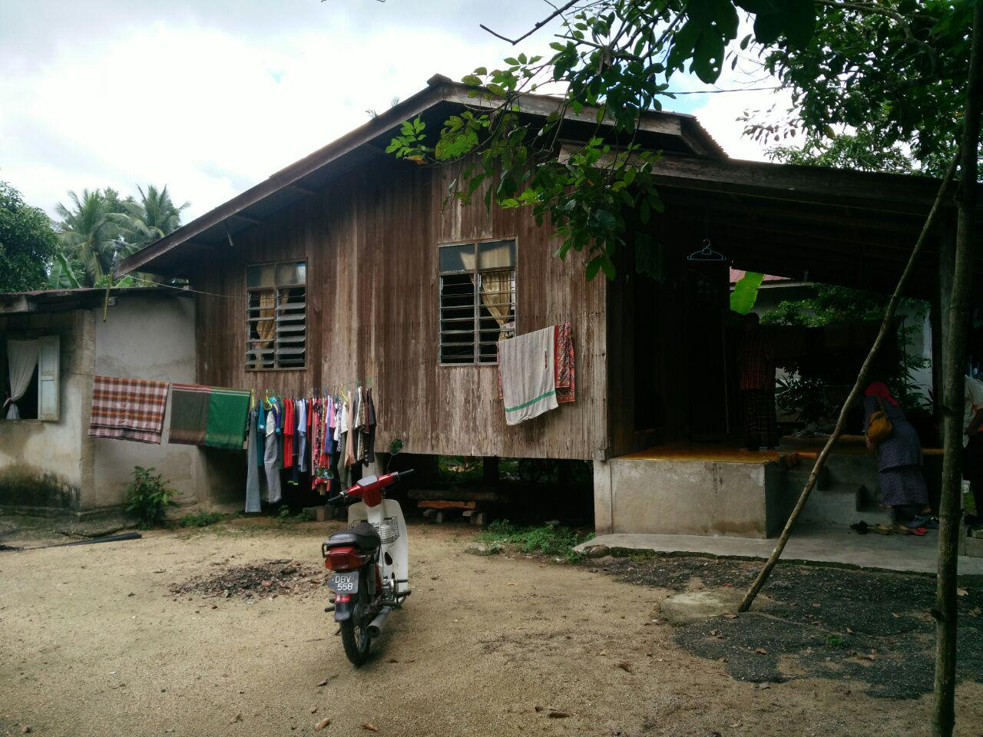

Figure 1: Condition of patient’s house from outside

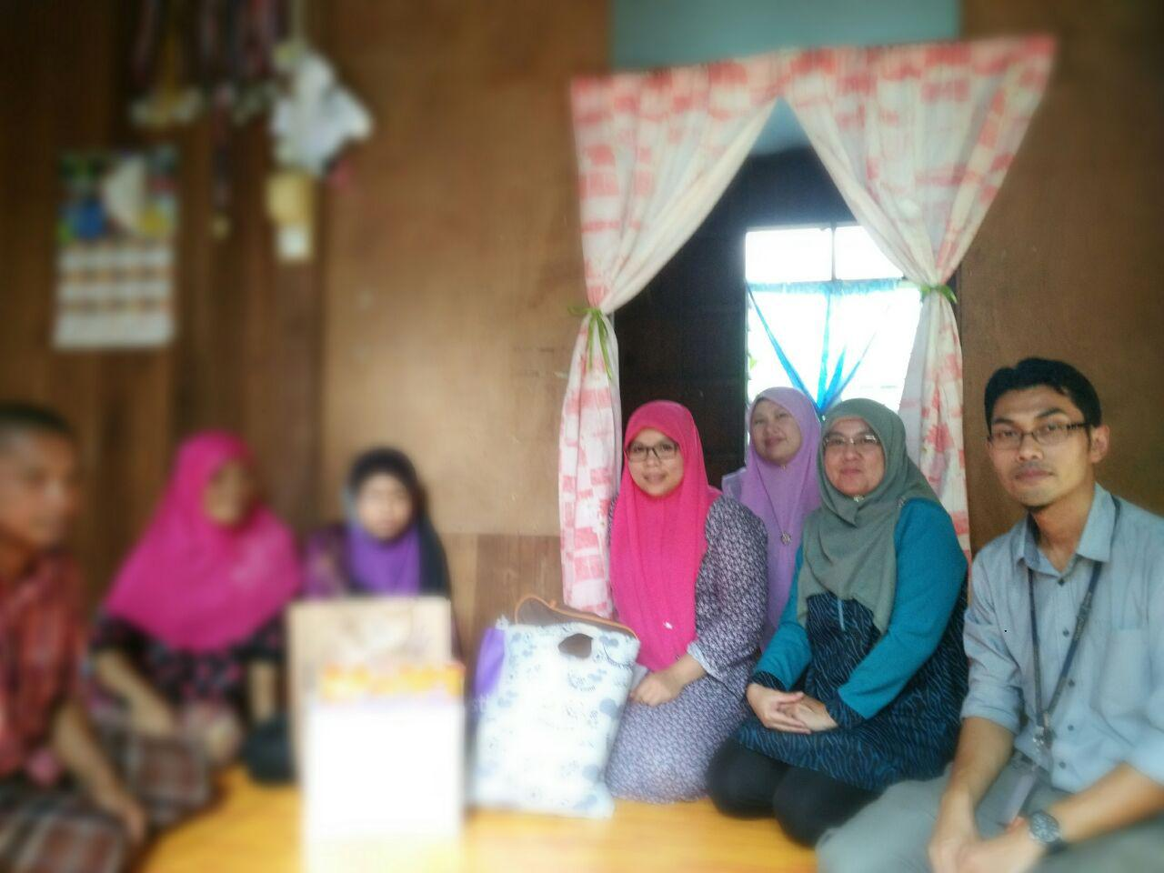

Figure 2: Home visit by the psychiatric and social welfare unit

- Patient belief and understanding of illness

  - Knowledge

Patient believed that her condition was related to the multiple life stressors that she faced. However, due to her introvert personality, pre-existing low self-esteem and poor coping style, she found it difficult to empower herself. She understood that her illness needed to be treated and she would need on-going supports in order to maintain healthy emotional and physical health as well as to cope with the duty of caring for her sick child.

  - Practice

Despite knowing about the nature of her problem, she was quite ambivalent about getting help. She was initially reluctant to take the prescribed anti-depressant due to concern regarding breastfeeding. She was also indecisive about her long-term plan given that the family was constantly pushing her to leave her husband. Her long-term adherence to treatment would largely depend on external factors such as family and resources available due to her financial and logistic limitations.

- Impact of illness

  - Patient

The depression has impacted on how she coped with duties as a wife and mother. Her incisiveness as a result of the depression and personality traits had made the situation become more complicated as she could not make proper decisions in her life. Continuous worry over her child’s health and constant pressure from the family and her marriage also interfere with her emotional well-beings.

  - Family

Her husband also struggled emotionally given the situation with her wife and her child. This was made worse with his enduring issue of addiction. He had difficulty in getting viable job which resulting in financial burden to her family. Her own family was trying at their level best to help with the care of both the patient and her child, despite their own limitation. The father had to work harder to sustain the family while her mother had to cope with duties as a caregiver while battling her own health issues.

- Assessment of patient need

  - Personnel support at home

The patient will need on-going physical and emotional support from the patient and the family, especially while recovering from her depression. The care of the child would also need to be among the top priority to ensure that the child continue to be healthy and safe.

  - Employment

Despite her education, she is currently unemployed. In a long term, show would need to find a stable job to improve the socio-economy of the family as well as empowering herself.

  - Community care

Given that major depression is a chronic relapsing illness, she would need long-term support in the community to ensure adherence to treatment and support. The primary care team, which will also involve in her child’s long-term care, will need to be involved in the management of the patient in the community. Apart from that, the role of local social welfare agency is also pertinent in ensuring the safety and wellbeing of the patient and her child in the community. The issues of neglect and risks will need to be monitored closely in future.

- Assessment on communication

  - Between patient and family members

The patient had problem in expressing her wish and opinion in the family. The clash between the family members has trapped her in a position where she could not stand for herself. The depression also contributed to this problem, which lead to many unresolved issues in her life.

  - Between patient and health workers

The patient was initially quite hesitant to accept help from the treating team. However, as her depression improved and the therapeutic alliance has been established, the patient was more cooperative with the treating team and did not have any communication issue. However, once she was discharged home, the treating team had some difficulties in getting in contact with her and her family member due to lack of access to electronic communication device. The only person who had an accessible mobile phone was the husband.

  - Between health facilities

Since there were many parties involved with her care, the main challenge was coordinating the management to ensure that she would adhere to the long-term management plan. The psychiatric team was initially playing the main role in coordinating the management of the patient and her child. Once she was discharged, the primary care team in the local health clinics would take over the role as the key player. Due to the logistic and communication issues, there have been some occasions where the information between the teams has been missed.

- Discussion

This patient was at risk of developing postpartum depression due to the various vulnerability factors such as her introvert personality traits, low self-esteem, poor coping skills and disadvantaged socio-economic status. The risk was amplified further with the presence of depressed mood during her pregnancy, stressful life events during pregnancy, child’s illness and low level of support, which were consistent with risk factors associated with postpartum depression as outlined in the systematic review by Robertson et al. (2004). The stress from a problematic relationship issue also plays a significant role in the development of postpartum depression (Kim et al., 2008). This issue was among the highlights of her stressors leading to her presentation. Even though in this case, the health of the baby was postulated to be one of the stressors, existing study showed that the child’s illness is not necessarily a precipitant of the mother’s depression. What was emphasised instead, was the additional burden of caring for a sick child that affects the risk of postpartum depression (Ueda et al., 2006).

As described in the management of this patient, multidisciplinary approach is warranted to ensure holistic management for both mother and the family. This should be the focus of the management due to the significant consequences of the illness, not only to the mother but also to the child and the family collectively. Poorly managed postpartum depression will not only have detrimental impacts on clinical prognosis of the patient, but also on the social, financial and legal outcome. Thus, the effective collaborative approach will ensure good immediate and long-term outcome (Clare & Yeh, 2012).

This collective approach in managing postpartum depression is more vital in the case of socially disadvantaged patients with multiple psychosocial issues, like represented in this case. This was supported further by various studies on multicomponent and multidisciplinary interventions for postpartum women in low-income countries (Rojas et al, 2007). The effective multidisciplinary approach should include the primary health care clinics and obstetrics team which will involve in perinatal care; paediatrics team which directly involved in postnatal follow-ups; social welfare units and psychiatric unit.

Nevertheless we should always acknowledge that this ideal approach comes with some challenges that may hinder its effectiveness. Based on what we learnt from this case, we could divide the challenges into patient-related factors and health system-related factors.

The patient-related factors involved limitations from the patients’ viewpoint to accommodate this approach. This includes poor social and financial support which lead to the difficulty in accessing the help and support offered to the patient. Patients from rural and remote areas, who are faced with logistic issues may not be able to access some support such as multiple visits for psychotherapy sessions, parenting skills training, education session and health check-up visits. In addition to that, involvement of various agencies and health care providers may also be perceived by the patients as an interference to their privacy, especially in certain ethnics and minority groups.

The health system-related factors on the other hand, includes the difficulty in getting various teams to work together in a coordinated way. This may be influenced by the territorial manner of working which hinder the effective communication between various teams. The lack of clear clinical guidelines also play a factor in this issue. Apart from that, certain parties also view this multidisciplinary approach as consuming too much time, effort and resources in practice. This, to some degree, is true considering that some areas in this countries are still deficient in term of available resources to implement this multidisciplinary management approach.

- Conclusion

Postpartum depression is a serious mental health issue among women especially in the context of poor socio-economic status. This case illustrates that a coordinated multidisciplinary approach in managing post-partum depression will be beneficial for both the depressed mother and the family. However, there are still many challenges that need to be addressed in order to ensure the optimum outcome is achieved. The local health care system should address these challenges and come up with a consensus in the form of clinical practice guidelines on how various parties involved could work together in a coordinated way in order to ensure the result is optimum.

Acknowledgement

We would like to acknowledge various individuals and health professionals who have provided direct and indirect inputs in the management of this case. This includes the psychiatric, paediatric and cardiothoracic team of Hospital Universiti Sains Malaysia, USM – Healing Little Heart Programme, Medical Welfare Unit Hospital Universiti Sains Malaysia, Jabatan Kebajikan Masyarakat Machang, Kelantan and Klinik Kesihatan Pulai Chondong.

References

Almond, P. (2009). Postnatal depression: a global public health perspective. Perspectives in public health, 129(5), 221-227.

Azidah, A. K., Shaiful, B. I., Rusli, N., & Jamil, M. Y. (2006). Postnatal depression and socio-cultural practices among postnatal mothers in Kota Bahru, Kelantan, Malaysia. The Medical journal of Malaysia, 61(1), 76-83.

Clare, C. A., & Yeh, J. (2012). Postpartum depression in special populations: a review. Obstetrical & gynecological survey, 67(5), 313-323.

Kim, Y. K., Hur, J. W., Kim, K. H., Oh, K. S., & Shin, Y. C. (2008). Prediction of postpartum depression by sociodemographic, obstetric and psychological factors: A prospective study. Psychiatry and clinical neurosciences, 62(3), 331-340.

Norhayati, M. N., Hazlina, N. N., Asrenee, A. R., & Emilin, W. W. (2015). Magnitude and risk factors for postpartum symptoms: a literature review. Journal of affective Disorders, 175, 34-52.

O'hara, M. W. (2009). Postpartum depression: what we know. Journal of clinical psychology, 65(12), 1258-1269.

Robertson, E., Grace, S., Wallington, T., & Stewart, D. E. (2004). Antenatal risk factors for postpartum depression: a synthesis of recent literature. General hospital psychiatry, 26(4), 289-295.

Rojas, G., Fritsch, R., Solis, J., Jadresic, E., Castillo, C., González, M., ... & Araya, R. (2007). Treatment of postnatal depression in low-income mothers in primary-care clinics in Santiago, Chile: a randomised controlled trial. The Lancet, 370(9599), 1629-1637.

Ueda, M., Yamashita, H., & Yoshida, K. (2006). Impact of infant health problems on postnatal depression: Pilot study to evaluate a health visiting system. Psychiatry and clinical neurosciences, 60(2), 182-189.

