Prophet Muhammad (PBUH): Mercy and Leadership for a Unified Society
by Nashwan Abdo Khaled and Shukran Abd Rahman
Islam is a comprehensive way of life that encompasses all aspects of human existence. It provides guidance in personal, social, legal, economic, political, educational, and other areas, enabling humans to attain hasanah (well-being) in this world and the hereafter. This holistic approach is beautifully captured in the concept of Rahmatan lil ‘Alamin (mercy to all creation), which serves as the foundational purpose of the Prophethood of Muhammad (Peace Be Upon Him), as reflected in the Qur'an: "And We have not sent you, [O Muhammad], except as a mercy to the worlds." (Al-Anbiya', 21:107) and further stated: “There has certainly come to you a Messenger from among yourselves. Grievous to him is what you suffer; [he is] concerned over you and to the believers is kind and merciful” (At-Tawbah: 128).
In these two verses, the Prophet Muhammad (PBUH) is described as Allah's Messenger who brings forth Islam—a complete way of life that serves as Rahmah or mercy to all of creation. The Prophet (PBUH) established guidelines for human relationships with their Creator, with one another, with the environment, and with all other creatures. These verses establish a profound framework for human values and universality that transcend time and space.
The Prophet Muhammad (PBUH) is a servant and messenger through whom Allah revealed the Qur'an. He paved the path of guidance for all of us to follow. In the Qur'an, Allah says: “Indeed, We have sent you as a witness and a bringer of good tidings and a warner, that you may believe in Allah and His Messenger, and honor him and respect the Prophet and exalt Allah morning and afternoon” (Al-Fath, 48:9). The Prophet (PBUH) has left us a complete way of life—ad-deen al-Islam—a gift beyond compare. He provided his example and conduct to demonstrate the practical teachings of Islam.
As for the Prophet (PBUH), let us link this discussion to the month of Rabi'ul Awwal, which is blessed with the significant point of Seerah for those who long for and love the Prophet (PBUH). The Islamic calendar records the 12th of Rabi'ul Awwal as the birthdate of the Prophet (PBUH). His birth marks the moment when the bright light of Islam began to shine across the world. Also known as Maulidur Rasul, this day is celebrated as a manifestation of our reverence and love for the Prophet (PBUH) and our gratitude to Allah, the Almighty.
It is noteworthy that while commemorating the birth of the Prophet (PBUH), it is essential to reflect on the lessons from the Seerah. One common practice among Muslims is to offer salawat (prayers) to the Prophet, an obligation for every believer. Scholars of tafsir (exegesis), such as Ibn Kathir and Al-Sa’di, when explaining the phrase وَتُوَقِّرُوهُ ("to honor him") in verse 9 of Surah Al-Fath, stated that acts of reverence toward the Prophet (PBUH) include respecting, venerating, and fulfilling his rights.
In manifesting our love for the Prophet (PBUH), it is vital to reflect on how we can emulate his interactions with his family, companions, and community. How can we be better teammates, supporters, and servants to one another? How can we create an environment where every member feels valued, where every voice is heard, and where everyone contributes to the collective well-being?
The salawat we offer does not single out the Prophet (PBUH) alone, but also includes his family members and companions. This indicates the involvement of the people the Prophet engaged with, consulted, and received support from. They are the people the Prophet cherished, valued, and respected. This shows that in guiding humanity to the pleasure of Allah, the Prophet (PBUH) was supported by companions who worked collectively to further his mission. They functioned like different parts of one body, each playing a vital role and collectively forming a resilient, dynamic unit. When faced with challenges, they rallied around each other, offering support and counsel, and shouldering the burdens of the mission together. This is the essence of a successful team: everyone contributes, supports, and shares in both trials and triumphs.
The above idea also highlights the need to embody the characteristics taught by the Prophet (PBUH) in building a supportive and dynamic community. We need to strive for excellence not just individually but collectively. The Prophet (PBUH) showed us that true success lies not only in individual achievements but also in the strength of our collective efforts. He taught us that when we stand together, support one another, and work dynamically as a team, we can overcome any challenge and achieve greatness.
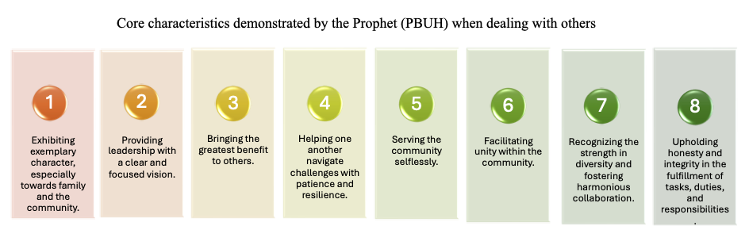
In short, the Prophet (PBUH) exemplified several fundamental practices that are valuable for individuals working in organizations. Among the core characteristics demonstrated by the Prophet (PBUH) are the abilities to:
- exhibit the best character, especially towards family and community. Good character creates a positive environment where team members feel valued and supported. When we practice kindness, empathy, and patience, we create a strong foundation for collective growth.
- provide leadership with a clear vision, evident in the Prophet’s (PBUH) ability to inspire others through his actions and guidance, fostering unity and purpose within the society.
- bring the most benefit to others, underscoring the importance of teamwork and cooperation. When each member of the community focuses on contributing to the betterment of others, the entire group becomes stronger and more dynamic.
- help each other navigate challenges with patience and resilience. The Prophet (PBUH) taught that the best among us are those who remain patient in the face of difficulties. When one member is down, it is essential that others lift them up, ensuring the group moves forward together.
- serve the community selflessly by adopting a mindset of service and creating a culture of mutual support, where everyone works towards the common good.
- facilitate unity among the community, where people of different backgrounds, tribes, and social statuses come together as brothers and sisters in faith.
- recognize the strengths of diversity and work together harmoniously.
- uphold honesty and integrity when accomplishing tasks, duties, and responsibilities. The Prophet (PBUH) emphasized truthfulness and ethical conduct, which are crucial in maintaining trust and credibility in the community.
There is a clear indication of the importance of ethics and the esteemed character of the Prophet Muhammad (PBUH), whom Allah praised for his noble and high morals: "And indeed, you are of a great moral character" (Al-Qalam: 4). These morals represent tolerance, openness, dialogue, respect, peaceful coexistence, winning hearts, and love for humanity. These principles will continue to serve as guiding lights that influence societies and nations, providing the foundation for building sound human relationships.
In conclusion, the message of the Prophet Muhammad (PBUH) focuses on building a society grounded in the highest human values and achieving well-being. The Prophet (PBUH) demonstrated the best ways of interacting with others and emphasized the importance of ensuring humanity’s well-being, making Islam a universal message of mercy. If studied in depth, the teachings of Islam should enable us to address and provide solutions to the increasingly complex challenges of today’s world

Dr. Shukran Abd Rahman is a professor of Industrial and Organisational Psychology in the Department of Psychology, AbdulHamid AbuSulayman Kulliyyah of Islamic Revealed Knowledge and Human Sciences, International Islamic University Malaysia. His research areas include career development, organizational behavior, academic culture, and employability of students in higher learning institutions.
Dr. Nashwan Abdo Khaled is an associate professor in the Department of Quran and Sunnah Studies, AbdulHamid AbuSulayman Kulliyyah of Islamic Revealed Knowledge and Human Sciences, International Islamic University Malaysia. His research areas include maqasid-based Qur'anic interpretation, Qur'anic sciences, and the management of Qur'anic education programs.

