TERMS OF REFERENCE

ARABIC EDUCATION CONFERENCE
Surakarta, December 17, 2022
Organized by
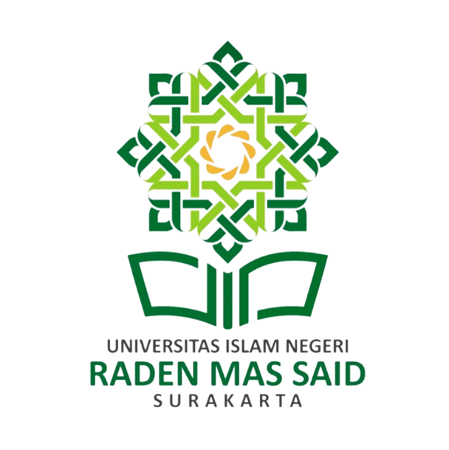

PRODI PENDIDIKAN BAHASA ARAB
FAKULTAS ILMU TARBIYAH
(Study Program of Arabic Language Education
Faculty of Ilmu Tarbiyah)

UNIVERSITAS ISLAM NEGERI RADEN MAS SAID SURAKARTA

- Name of Conference
Arabic Education Conference (AEC) and Call for Papers Study Program of Arabic Language Education, theme: تعليم اللغة العربية لغير الناطقين بالعربية في ضوء التكنولوجيا الحديثة.

Background of Conference
The current Covid-19 pandemic has changed all human life elements, starting from the social, cultural, economic, religious, and educational fields. Everything goes abnormally. Education is one aspect of life affected by the pandemic, so the educational learning process that was originally conventional (face-to-face in class) must be transformed into online or online learning that can be done without being limited by place and time.
This pandemic seems to be a process of accelerating the transition of the industrial revolution 4.0 towards the era of society 5.0. The new civilization based on technological innovation, which was introduced by Japan in 2019, needs to be recognized as having a major impact on the education sector. Era Society 5.0 is a collaborative process between humans as the center (human-centered) and technology as the basis (technology-based). It means. Education era 5.0 is an educational process that focuses on human development as creatures who have reason, knowledge, and ethics supported by the development of modern technology today.
Ten skills that must be possessed in the world economic forum are formulated to face the super smart society. The three highest skills needed are the ability to solve complex problems, critical thinking, and creativity. Mastery of the three main skills needed is the responsibility of the world of education, including Arabic language education.

Facing the conditions of the movement from the Industrial 4.0 era to the Society 5.0 era, Arabic language education must be ready to anticipate and overcome any changes. Through the right education concept and system, Arabic language education graduates will be ready to accept the challenges and opportunities that occur in the Industry 4.0 and Society 5.0 era.

From this background, the Study Program of Arabic Language Education faculty of Ilmu Tarbiyah of Universitas Islam Negeri Raden Mas said Surakarta intends to hold an international conference (AEC: Arabic Education Conference) and call papers by theme “تعليم اللغة العربية لغير الناطقين بالعربية في ضوء التكنولوجيا الحديثة”. This international conference intends to produce various solutions and innovative thoughts related to the problems that depend on the theme.

Purpose
AEC (Arabic Education Conference) aims to discuss various problems of Arabic Language Education in the era of society 5.0 and find solutions to various problems faced. Finding creativity and innovation related to methods, media, teaching materials, and evaluation of Arabic learning.

Schedule and Place
Day : Saturday
Date : December 17, 2022
Time : 08.00 am – 04.00 pm via zoom
Place : Zoom Meeting.

Saturday, December 17, 2021
Time | Segment | PIC
08.30-09.00 am | Preparation | Committee
09.00-09.50 am | Opening  - Sing the Indonesian national anthem (Indonesia Raya)  - Speech from the Head of Study Program  - Speech from the Dean of the Faculty of Tarbiyah | Committee
09.50-10.00 am | Coffee Break | Committee
10.00-12.00 am  10.00-10.20 am  10.20-10.40 am  10.40-11.00 am  11.00-11.30 am | Conference  Learning Arabic in the era of society 5.0  Arabic Learning Model in the era of society 5.0  Arabic Learning Media in the era of society 5.0  Response | - Prof. Dr. Arifin Bin Mamat  (International Islamic University of Malaysia)  - Dr. Hanik Mahliatussikah, M.Hum.  (Universitas Negeri Malang/Director of PPPBA)  - Dr. Hafidah, M.Ag  (UIN Raden Mas Said Surakarta)
11.30-01.00 pm | Break | Committee
01.00-03.00 pm | Parallel Session | Committee
03.00 pm | Closing | Committee

Participant
The number of participants for this activity is around 200. Participants of the international conference and call for papers are:
  - Lecturer
  - Teacher (SMP/MTs, SMA/SMK/MA),
  - Student (Mahasiswa) of S1, S2, dan S3,
  - Educational practitioners and researchers,

Organizer
The organizers of this activity are the Bachelor (S1) and Master (S2) Programs in Arabic Language Education, Faculty of Tarbiyah, UIN Raden Mas Said Surakarta.

Closing
Thus the Term of Reference regarding AEC (Arabic Education Conference) activities and Call For Papers on Arabic Language Education is made so that it can be taken into consideration as it should be.
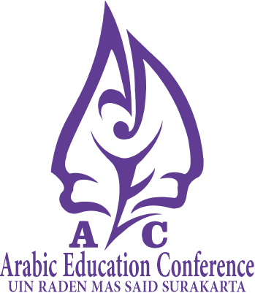
Surakarta, October 24, 2022
Chairman of the committee

Muhammad Zaenuri, M.Pd.
NIP. 198901252019031004

