Number : 03/AEC-UINRMS/X/2022 October 11, 2022
Attachment : -
Subject : Application to be a Resource Person

To.
Prof. Dr. Arifin Bin Mamat
(International Islamic University of Malaysia)
In Place

Assalamu’alaikum Wr. Wb.
With Respect,
Faculty of Ilmu Tarbiyah of Universitas Islam Negeri Raden Mas said Surakarta intends to hold an international conference (AEC: Arabic Education Conference) and call papers.
In connection with this, we also intend to invite you to attend our seminar to be conducted on :
Day/Date : Sabtu, 18 Desember 2022
Time : 09.00 WIB- Selesai
Place : Zoom Meeting

We ask you to be a speaker at the Arabic Education Conference” (AEC)
Given the importance of this conference, then we strongly expect the presence to be able to participate in that event.
So we pass on this invitation, on attention and presence we say thank you.
Wassalamu’alaikum Wr. Wb.

Surakarta, October 11, 2022

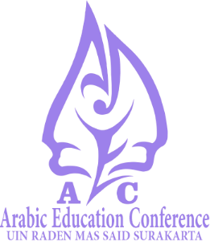
Head of AEC 2022,

Muhammad Zaenuri, M.Pd.

NIP. 198901252019031004

